StressAway

Final Year Project
Session 2022-2026

A project submitted in partial fulfillment of the degree of
BS in Software Engineering


Department of Software Engineering
Faculty of Computer Science & Information Technology
The Superior University, Lahore

Fall 2022
Type (Nature of project) |  |  | [ ] Development [ ] Research [ ] R&D
Area of specialization |  |  | Web Development
FYP ID |  |  | BSSE-FYP-F25-009
Project Group Members
Sr.# | Reg. # | Student Name |  | Email ID | *Signature
(i) | BSSEM-F22-251 | Abdul Haseeb |  | su92-bssem-f22-251@superior.edu.pk
(ii) | BSSEM-F22-232 | Talal Babar |  | su92-bssem-f22-232@superior.edu.pk
(iii) | BSSEM-F22-252 | Abubakar |  | su92-bssem-f22-252@superior.edu.pk
*The candidates confirm that the work submitted is their own and appropriate credit has been given where reference has been made to work of others
Plagiarism Free Certificate
This is to certify that, I Abdul Haseeb Son of Muhammad Ashraf, group leader of FYP under registration no BSSEM-F22-251 at Software Engineering Department, The Superior University, Lahore. I declare that my FYP report is checked by my supervisor.

Date: _________ Name of Group Leader: Abdul Haseeb Signature: _____________
Name of Supervisor: Mr. Syed Zeeshan Hussain Co-Supervisor: Mr.Ali Ahmed
Designation: Lecturer Designation: Senior Lecturer
Signature: ________________ Signature: _________________

HoD: Dr. Tehreem Masood
Signature: _______________
StressAway

Change Record
Author(s) | Version | Date | Notes | Supervisor’s Signature
Abdul Haseeb | 1.0 | 15-09-2025 | Completed Chapter 1
Talal Babar | 1.1 | 30-09-2025 | Worked on Chapter 2 & 3
Abdul Haseeb | 1.2 | 07-10-2025 | Corrected Chapter 2 & 3
Abdul Haseeb | 1.3 | 21-10-2025 | Started Chapter 4
Abdul Haseeb | 1.4 | 07-11-2025 | Partially Completed Chapter 4
Abu Bakar | 1.5 | 15-11-2025 | Completed Chapter 5
Abdul Haseeb | 1.6 | 24-11-2025 | Completed Chapter 4 and taken feedback from supervisor
Abdul Haseeb | 1.7 | 05-12-2025 | Corrected whole documentation based on supervisor’s feedback
Abdul Haseeb | 1.8 | 08-12-2025 | Final Changes
Abdul Haseeb | 1.9 | 18-12-2025 | Changes based on evaluator’s feedback
Abdul Haseeb | 2.0 | 12-04-2026 | Completed Chapter 6
Abdul Haseeb | 2.1 | 15-04-2026 | Completed Chapter 7

APPROVAL
Project Supervisor
Comments: ___________________________________________________________________
_____________________________________________________________________________
Name:______________________________
Date:_______________________________ | Signature:__________________________

Project Manager
Comments: ___________________________________________________________________
_____________________________________________________________________________
Date:_______________________________ | Signature:__________________________

Head of the Department
Comments: ___________________________________________________________________
_____________________________________________________________________________
Date:_______________________________ | Signature:__________________________

Dedication

This project is dedicated to everyone, who experiences stress, anxiety, and mental health issues. Hopefully this project can help in a little bit to make the world a better place by enhancing mental health and offering an affordable support to needy individuals. I also dedicate this work to my family, friends and mentors that inspired and motivated me on this journey and who guided, motivated and gave me unending support especially my teachers who taught and instructed me from class 1 till now.

Acknowledgements

I would like to greatly appreciate all those who helped me succeed in the completion of this Final Year Project. To begin with, I would like to express my deepest gratitude to my supervisor, Mr. Syed Zeeshan Hussain because he was always available to guide me, provide me with valuable feedback, and encourage me throughout the project. I also thank my family that was always supportive, patient, and encouraging and enabled me to overcome the difficulties in the process of developing this platform and project. I would like to give particular credit to my teachers, mentors and online development community that provided information, material and technical support in the implementation of modern tools and techniques. Lastly, I wish to thank my team who gave feedback and suggestions, and made sure that this platform would be useful, convenient, and effective in facilitating mental health.

Executive Summary
Stress is one of the problems that have emerged as a big concern in the world today in terms of health and as such results to many psychological disorders such as anxiety, depression and inability to be productive. Despite the traditional mental health options, such as apps like Calm and Moodfit and even psychological services of a professional psychologist, they are quite restrictive (regarding access and affordability) and interaction. This leads to the development of growing need in a combined, convenient and cost-efficient platform to enhance mental health.
This is a project called StressAway, this aims to develop and conceptualize a mental wellness web-based product to assist its users to monitor and analyze their level of stress to effectively manage it. The system is designed with robust user registration and authentications, which enable the users to calculate and to take notes on their level of stress by using standardized questionnaires and most importantly by analyzing their facial expression. The entire stress measures are stored and represented through time with interactive dashboards and therefore users can track their emotional health and trends. In order to make users more engaged StressAway will introduce new features, such as ability to suggest emoji-based and other wellness activities, emotion recognition, AI based chatbot which will make real-time suggestions strategies. The platform also encourage connectivity since the user is able to connect with family members, in addition, professional psychologists over special modules. Additionally, they have individualized dashboards, which can make psychologists and admins to measure the progress of the user, interpret stress levels and follow through scores. The fact that there is an SOS system is also a significant safety feature of the system since, once the stress level of the user surpasses a certain threshold, the SOS system will be activated. In this situation, alerts to specific SOS contacts are sent, as well as guidelines to address a professional psychologist.
Overall, StressAway will serve to bridge the two poles of self-help solutions and professional mental health care with an ecosystem of holistic, accessible and entertaining solutions. The platform additionally prides itself on the use of new technological developments in promoting mental health, and can be considered an important component of digital health development.

Table of Contents
Chapter 1 1
Introduction 1
1.1. Background 2
1.2. Motivations and Challenges 2
1.3. Goals and Objectives 3
1.4. Literature Review/Existing Solutions 3
1.5. Gap Analysis 3
1.6. Proposed Solution 4
1.7. Project Plan 5
1.7.1. Work Breakdown Structure 5
1.7.2. Roles & Responsibility Matrix 7
1.7.3. Gantt Chart 9
1.8. Report Outline 9
1.8.1. Chapter 1: Introduction 9
1.8.2. Chapter 2: Software Requirement Specifications (SRS) 10
1.8.3. Chapter 3: Use Case Analysis 10
1.8.4. Chapter 4: System Design 11
1.8.5. Chapter 5: Implementation 11
1.9. Empathy Map 12
Chapter 2 14
Software Requirement Specifications 14
2.1. Introduction 15
2.1.1. Purpose 15
2.1.2. Document Conventions 15
2.1.3. Intended Audience and Reading Suggestions 15
2.1.4. Product Scope 16
2.1.5. References 16
2.2. Overall Description 18
2.3. External Interface Requirements 21
2.4. System Features 23
2.5. Nonfunctional Requirements 25
2.6. Domain Requirements 26
Chapter 3 27
Use Case Analysis 27
1.1. Use Case Model 28
1.2. Use Cases Description 29
Chapter 4 36
System Design 36
4.1. Architecture Diagram 37
4.2. Domain Model 39
4.3. Entity Relationship Diagram with data dictionary 40
4.4. Class Diagram 44
4.5. Sequence Diagram 45
4.6. Operation contracts 47
4.7. Activity Diagram 57
4.8. State Transition Diagram 60
4.9. Component Diagram 61
4.10. Deployment Diagram 61
4.11. Data Flow diagram 62
4.11.1. Data Flow Diagram Level-0 62
4.12.2. Data Flow Diagram Level-1 63
Chapter 5 64
Implementation 64
5.1. Important Flow Control/Pseudo codes 65
5.2. Components, Libraries, Web Services and stubs 67
5.3. Deployment Environment 67
5.4. Tools and Techniques 67
5.5. Best Practices / Coding Standards 68
5.6. Version Control 68
Chapter 6 69
Testing and Evaluation 69
6.1. Use Case Testing 70
6.2. Equivalence partitioning 72
6.3. Boundary value analysis 72
6.4. Data flow testing 73
6.5. Unit testing 73
6.6. Integration testing 74
6.7. Performance testing 74
6.8. Stress Testing 75
Chapter 7 76
Summary, Conclusion and Future Enhancements 76
7.1. Project Summary 77
7.2. Achievements and Improvements 77
7.3. Critical Review 78
7.4. Lessons Learnt 78
7.5. Future Enhancements/Recommendations 79
Appendices 80
Appendix A: Promotional Material 81
Appendix B: Stress Assessment and Classification Methodology 82
Appendix C: System Design and Architecture 84
Reference and Bibliography 87
Index 89

List of Figures
Figure 1: Work Breakdown Structure 5
Figure 2: Gantt Chart 9
Figure 3: StressAway Context Diagram 17
Figure 4: Use Case Diagram 28
Figure 5: Architecture Diagram 36
Figure 6: Domain Model Diagram 38
Figure 7: ERD Diagram 39
Figure 8: Class Diagram 43
Figure 9: Sequence Diagram 1 44
Figure 10: Sequence Diagram 2 45
Figure 11: Sequence Diagram 3 46
Figure 12: Activity Diagram 1 56
Figure 13: Activity Diagram 2 57
Figure 14: Activity Diagram 3 58
Figure 15: State Transition Diagram 59
Figure 16: Component Diagram 60
Figure 17: Deployment Diagram 60
Figure 18: Data Flow Diagram Level 0 61
Figure 19: Data Flow Diagram Level 1 62

List of Tables
Table 1: Roles & Responsibility Matrix 7
Table 2: Empathy Map 12
Table 3: Empathy Map Format No.2 13
Table 4: Product Perspective (User Classes And Characteristics) 18
Table 5: Data Dictionary For ERD Diagram Tables Separately 39

Chapter 1

Introduction

Chapter 1: Introduction
Many people lack easy to access tools to identify, track and manage their stress effectively. The StressAway platform will provide a personalized stress management experience where users can record their stress levels, visualize progress and receive AI driven suggestions. Family and psychologists can optionally be connected to provide additional support. This is for students, professionals and general users facing daily stress and need a reliable platform.

Background
In today’s world, stress has become one of the most common and concerning issue for people of all ages. Academic pressure, workload, social challenges, and financial instability have made individuals more exposed to stress, anxiety and depression. The continuous exposure to such stress reduces people’s concentration, productivity, and overall quality of life. Although many mobile applications and professional services like psychologists exist to relieve stress, most users find them either costly or time consuming. Hence, there is a need for an easily accessible, affordable, and an interactive digital platform that helps people to manage their stress levels effectively.

Motivations and Challenges
StressAway is all about making mental wellness more accessible to everyone, we want to close the gap between what a pro can do and what you can do on your own with a tech gadget like mobile or laptop. Our goal is to create a place where people can track your stress levels at any time, day or night. The tricky part is figuring out how to turn self-reporting (those questionnaires) and face analysis into a stress score that actually means something. But that's not all, we've also got to make sure the AI suggestions that pop up are genuinely helpful and show we actually care. We also need to sort out how to keep user’s info safe and secure, and design an interface that actually gets people using the thing so they'll stick with it.

Goals and Objectives
The main goal of StressAway is to encourage users to monitor, understand, and manage their stress effectively through our platform. The objectives of SressAway are following:
- Develop a secure and user-friendly web platform for user’s stress management.
- Implement stress calculation using different questions and face expression analysis.
- Enable users to log and visualize their stress daily or a specific time span through interactive dashboards.
- Include separate professional dashboards for psychologists and admins.
- Include an AI-powered chatbot that offers real time suggestions.
- Include fun, emoji-based activities and physical outdoor activities/exercises.
- Include psychologist connection feature for proper treatment in case of high stress levels.
- Include family connection feature and describe family tree as well in a separate module.
- Include an SOS alert system that notifies family or professional psychologists when needed.

Literature Review/Existing Solutions
Currently stress platforms like Calm, Headspace and Moodfit etc… gives medicines, mood tracking systems. However, these systems only focus on a single domain such as medicines for sleep and suggestions that are hard coded/static text only and haven’t integrated features like Ai Suggestions, emoji-based activities, physical outdoor activities, implementation of family tree and connections with psychologists and family.

Gap Analysis
Competitors:
- Headspace: Sleep meditation.
- Calm: Sleep medication and online therapy.
- Moodfit: Mood/nervous system wellness.
Key limitations of existing systems:
- No visual dashboards for stress logs.
- No family or psychologist’s involvement.
- No personalized suggestions.
- High subscription charges.
Our platform StressAway differ from all these in following features:
- Visual dashboards for stress logs.
- Ai based suggestions.
- Psychologists and family connections.
- Personalized chatbot.
- Separate dashboards for admins, psychologists and users to view trends of stress levels over time.

Proposed Solution
StressAway is a web-based platform with modules for stress tracking, visualization, AI-driven suggestions, chatbot, family connectivity and psychologist consultations. Users can:
- Register/login.
- Calculate and log daily stress levels through AI analysis.
- View historical stress logs via dashboards and graphs.
- Get AI-generated suggestions (relaxation tips, breathing exercises, activity recommendations).
- Chat with an interactive chatbot.
- Implement emoji based fun activities and outdoor physical activities suggestions to lift user’s mood.
- Connect with psychologists for professional help.
- Connect with family, friends or relatives, also describe family tree.

Project Plan
Different phases of the software development life cycle (SDLC) will be used to develop the project. These phases are requirements analysis, architecture design, system design, implementation, testing and deployment. The agile methodology will be utilized for the development of this project to allow iterative improvements and constant feedback from supervisor. The project timeline is 32 weeks, broken down into planning, developing, integrating and evaluating phases. We will have regular meetings with the team and supervisor to ensure that the system made is right.

Work Breakdown Structure
Diagram:
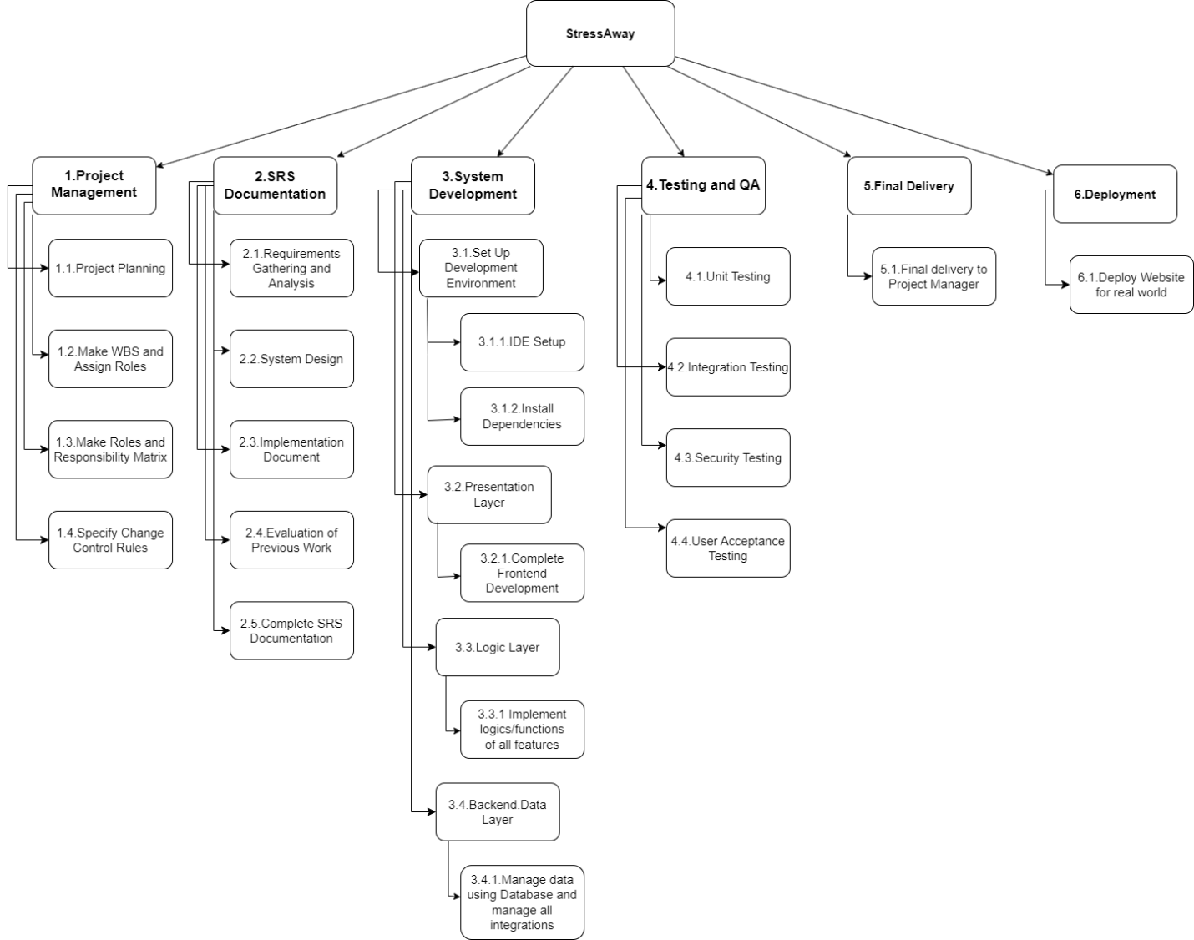
Figure 1: Work Breakdown Structure
1. Project Management
1.1 Project Planning
1.2 Make WBS & Assign Roles
1.3 Make Responsibility Matrix
1.4 Specify Change Control Rules
2. SRS Documentation
2.1 Requirement Analysis
2.2 System Design
2.3 Implementation Document
2.4 Evaluation of previous work
2.5 Complete SRS Documentation
3. System Development
3.1 Set Up Development Environment
3.1.1 IDE Setup
3.1.2 Install Dependencies
3.2 Presentation Layer
3.2.1 Complete Frontend Development
3.3 Logic Layer
3.3.1 Implement logics/functions of all features
3.4 Backend/data Layer
3.4.1 Handle User Data
3.4.2 Handle Stress Logs
3.4.3 Handle Chat Logs
3.4.4 Api integration for stress calculator and chatbot
4.Testing
4.1 Unit Testing
4.2 Integration Testing
4.3 Security Testing
4.4 User Acceptance Testing
5.Final Delivery
5.1 Final delivery to Project manager
6.Deployment
6.1 Deploy Website for Real World

Roles & Responsibility Matrix
The purpose of roles & responsibility matrix is to identify who will do what.
Table 1: Roles & Responsibility Matrix
WBS No. | WBS Deliverable | Activity | Activity to Complete the Deliverable | Duration  (# of Days) | Responsible Team Member
1.1 | WBS & Roles | 1 | Create & get Approved WBS | 7 days | Team Lead
1.1 | Responsibility Matrix | 2 | Matrix | 7 days | Team Lead
1.3 | Change Control | 3 | Discussion with supervisor | 7 days | Team Lead
2.1 | Requirement Analysis | 4 | Collect & Document | 14 days | Whole Team
2.2 | Whole system Design | 5 | System design | 28 days | Team Lead
2.3 | Implementation Docs | 6 | Implementation of previous work | 14 days | Whole Team
2.4 | Evaluation of previous work | 7 | Evaluation/verification of work | 14 days | Whole Team
2.5 | Final Documentation | 8 | Full System document | 14 days | Whole Team
3.1.1 | IDE Setup | 9 | Full IDE/Dev Setup | 7 days | Whole Team
3.1.2 | Database Setup | 10 | Database Setup | 7 days | Whole Team
3.2.1 | Web Dashboard | 11 | Stress Log Dashboard | 14 days | Whole Team
3.2.2 | Chatbot | 12 | Chatbot Frontend | 14 days | Team Lead
3.2.3 | Emoji Activities | 13 | Emoji activity frontend | 14 days | Team Lead
3.3.1 | Stress Calculator | 14 | Stress Calculation | 14 days | Team Lead
3.3.2 | AI Suggestions | 15 | Ai suggestion integrate | 14 days | Whole Team
3.3.3 | Connectivity Module between user and psychologists | 16 | Connection module | 4 days | Whole Team
3.3.4 | Connectivity Module between user and family, friends and relatives | 17 | Connection module | 3 days | Whole Team
3.4 | Data handling | 18 | Do all backend work | 14 days | Whole Team
4 | Testing | 19 | Test whole system | 7 days | Whole Team
5 | Final delivery to Project Manager | 20 | Delivery and viva to PM | 2 days | Whole Team

Gantt Chart
Figure 2: Gantt Chart

Report Outline
This report represents the design and development process of the StressAway which is a
web-based mental wellness platform. The report is divided into five chapters, each one is focusing on different aspects of the project and are discussed in detail below.

Chapter 1: Introduction
This chapter gives an overview of the following aspects:
- Problem domain and background.
- Project objectives.
- Existing solutions.
- Motivation.
- Project plan.
- Scope of the project.
This chapter shows the importance of stress management and the role of digital wellness platforms. The chapter sets the context for the development of our platform StressAway and explains the expected outcomes of the project.

Chapter 2: Software Requirement Specifications (SRS)
This chapter describes the introduction, purpose, document conventions, intended audience and reading suggestions, system requirements including both functional and non-functional requirements, product scope, overall description, dependencies, and references. It explains on system features such as:
- User registration and authentication for login.
- Stress level calculation.
- AI chatbot integration.
- Family connection module.
- Stress logs views via dashboards and graphs.
- AI-generated suggestions (relaxation tips, breathing exercises, activity recommendations).
- Emoji based fun activities and outdoor physical activities suggestions to lift user’s mood.
- Psychologist’s connection module.
The chapter ensures that all user and system requirements are clearly documented to guide the subsequent design and development phases.

Chapter 3: Use Case Analysis
This chapter shows the interactions between users and the system. It includes:
- Identification of actors (In this case: user, admin, family member, chatbot).
- Details of major use cases.
- Use case diagrams to visually represent system interactions.
This chapter helps us in understanding user needs and system’s behavioral before going into design phase.

Chapter 4: System Design
The design chapter shows the system architecture and provides visual representations of the system design and data flow of our system. It includes:
- System architecture diagram.
- Domain model.
- Data Flow Diagrams (DFDs).
- Entity-Relationship Diagram (ERD).
- UML diagrams (class, sequence, and activity diagrams).
- Database schema and module interaction design.
- Deployment and component diagram.
This chapter explains how the different modules integrate and perform functions to achieve the whole system objectives.

Chapter 5: Implementation
This chapter describes the tools, frameworks, and technologies used to develop and implement the StressAway platform. It presents:
- Backend and frontend development details like tools and techniques and whole deployment environment.
- Important flow controls/pseudo codes.
- Database integration process.
- Coding standards/best practices.
- Key components used in developments and screenshots of the UI of implemented system.
- Testing and debugging procedures.
- Version control.
This chapter shows how the conceptual design was implemented into a functional and user-friendly web application.

Empathy Map
Table 2: Empathy Map
User | Says (What they hear/say about stress and wellness) | Thinks (What they believe about mental wellness) | Does (What actions they take) | Feels (Emotional state regarding the problem)
Working Professional/Student | I don't have time to see a therapist.  My job/studies are too demanding. I wish I had a quick way to vent. | Stress is normal, but I'm losing productivity. I need an easy, private way to check in on myself. Mental health wellness resources are too expensive or intimidating. | Skips meals, drinks more coffee, procrastinates, uses social media as a distraction, searches for 'quick fixes' online. | Overwhelmed, Guilty about lost productivity, Anxious about the future, Isolated.
Family Member | I'm worried about them. They seem distant lately. I don't know what to say to help. | "I wish I could remotely monitor their well-being." "I need a non-intrusive way to connect and offer support." | Calls/texts sporadically, expresses general concern, tries to encourage 'taking a break.' | Concerned, Helpless, Frustrated by the lack of insight into their loved one's state.
Psychologist/Admin | Patient self-reporting is often inaccurate. It's hard to track progress between sessions. I need data to back up treatment plans. | Consistent data is key to effective intervention. An accessible digital tool can extend the reach of care. | Maintains paper/digital patient records, conducts scheduled sessions, adjusts therapy based on verbal feedback. | Dedicated,  Challenged by limited real-time data,  Seeking efficient ways to manage client load.

Table 3: Empathy Map Format No.2
Section | Description
Who are we empathizing with? | Users experiencing stress, anxiety, or depression who need an affordable, accessible, and interactive platform for monitoring and improving their mental health.
What do they need to do? | Users need to identify their stress levels, get recommendations, connect with psychologists or family members, and engage in wellness activities to reduce stress.
What do they see? | They see an interactive dashboard, AI chatbot, visual stress analysis graphs, emoji-based activities, and personalized suggestions for mental wellness.
What do they hear? | Positive affirmations and real-time chatbot responses that motivate them; support and guidance from family members or psychologists through the system.
What do they think and feel? | Users often feel overwhelmed, anxious, or lonely. They seek understanding, motivation, and a safe digital environment to manage emotions without judgment.
What do they say and do? | They express concerns about workload, personal stressors, or emotional instability and seek digital tools that offer instant feedback and relief activities.
Pain Points | High cost of therapy, privacy concerns, lack of accessible mental health tools, difficulty tracking progress, and limited motivation for self-care.
Gains | Affordable stress tracking, accessible AI support, real-time insights, improved emotional awareness, and a stronger support system through connected family and psychologist networks.

Chapter 2

Software Requirement Specifications

Chapter 2: Software Requirement Specifications

Introduction

Purpose
This document specifies the software requirements for the StressAway which is a web-based wellness platform designed to help users track, analyze, and manage their stress levels. It defines the system’s functional and non-functional requirements, user interactions, constraints, and performance goals. The purpose of this SRS is to guide developers, designers, and stakeholders including teachers, supervisors, project managers and Head of Department throughout the
Software development lifecycle (SDLC).
This document covers the whole system, including user registration and login, stress calculation, stress logs, dashboards for respective users, chatbot interactions, family and psychologist connections, and emergency alerts.

Document Conventions
This document follows IEEE SRS documentation standards.
- Font: Calibri, size 12 pt.
- Line Spacing: 1.5.
- Headings: Hierarchical numbering is used in bold text.
- Requirements format: Each requirement is uniquely named and numbered.
(e.g.: REQ-SF1-1).
- Priority: Priorities are High, Medium, and Low.
- Any information that is not complete will be denoted with [TBD].
All requirements inherit their parent level priorities unless specified manually.

Intended Audience and Reading Suggestions
This document is created for following person/audience:
- Student’s team: To understand functional and non-functional requirements for implementation.
- Project managers and other evaluators: To assess the system and evaluate it.
- Project supervisor: To review, assess, and monitor the project’s progress and compliance with the given format of documentation.
- Student tester team: To create test cases and validation criteria.
- End users: To understand system capabilities and usability features.
Readers are recommended to begin with the Introduction and Executive summary sections for a basic understanding before moving to System Features and Requirements.

Product Scope
StressAway will be a low cost, interactive, and AI enabled wbsite that bridges the gap between the stress monitoring and stress reduction process. The system will enable users to measure stress using facial recognition and questionnaires, plot trends, and give them wellness recommendations. It is also a self-help and professional care bridge as it allows users to reach psychologists and family.
The key objectives are:
- Constant care of mental health.
- Increasing user engagement and motivation.
- Introduce stress measurements that are knowledgeable by data.
- Enhancing the easy access to mental health/stress support by implementing professional psychologist’s connection module.

References
[1] Vercel, “Next.js Documentation” USA, 2023.
Link: https://nextjs.org/docs
[2] NestJS, “NestJS Backend Framework Documentation” USA, 2023.
Link: https://docs.nestjs.com
[3] Supabase, “Supabase Backend as a Service Documentation” USA, 2023.
Link: https://supabase.com/docs
[4] tensorFlow.js, “Machine Learning for Web Applications” Google, USA, 2023.
Link: https://www.tensorflow.org/js
[5] OWASP Foundation, “Top 10 Web Security Risks” USA, 2021.
Link: https://owasp.org/www-project-top-ten
[6] World Health Organization (WHO), “Mental Health and Stress Management Report” Switzerland, 2020.
Link: https://www.who.int/news-room/fact-sheets/detail/mental-health
[7] Calm App, Website, USA, 2026.
Link: https://www.calm.com
[8] Moodfit App, Website, USA, 2026.
Link: https://www.getmoodfit.com
[9] A. Mollahosseini, B. Hasani, M. H. Mahoor, “AffectNet: Facial Expression Dataset for Emotion Recognition” IEEE Transactions on Affective Computing, USA, 2019.
Link: https://ieeexplore.ieee.org/document/8103145
[10] P. Ekman, “Basic Emotions and Facial Expressions Research” APA Journal, USA, 1971.
Link: https://psycnet.apa.org/record/1972-23941-001
[11] I. Goodfellow et al., “FER2013 Dataset for Facial Emotion Recognition” Kaggle Dataset, USA, 2013.
Link: https://www.kaggle.com/datasets/msambare/fer2013
[12] A. Krizhevsky et al., “CNN for Image Classification (ImageNet)” NIPS, USA, 2012.
Link: https://papers.nips.cc/paper/2012/file/c399862d3b9d6b76c8436e924a68c45b-Paper.pdf
[13] R. Pressman, B. Maxim, “Software Engineering: A Practitioner’s Approach” McGraw Hill, USA, 2015.
Link: https://www.mheducation.com
[14] MDN Web Docs, “JavaScript and Web Development Guide” Mozilla, 2023.
Link: https://developer.mozilla.org

Overall Description

Product Perspective
StressAway is a web-based application that integrates AI modules, emotion recognition, and stress logs and database driven dashboards. It is not a replacement for any existing system but it is a better web platform than current solutions that integrates stress monitoring, AI assistance, and professional psychologist’s connections/consultations into a single system. It uses following technologies for development:
- Flask/Node.js (backend).
- React.js/Next.js (frontend).
- MySql/MongoDB for data management.

2.2.1.1 Context Diagram
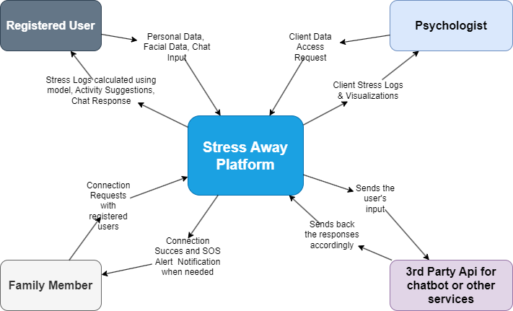
Figure 3: StressAway Context Diagram

User Classes And Characteristics
Table 4: Product Perspective (User Classes And Characteristics)
User Class | Description | Characteristics | Priority
Registered Users | Users seeking to monitor and manage their own stress. Registers, calculates stress level, interacts with chatbot, and tracks progress. | Basic technical proficiency. Want to find easy, affordable solutions. | High
Psychologist | Licensed mental health professionals connected to the platform. | High professional and ethical standards. Need secure access to relevant client data, stress logs, and progress charts. | High
Admins | Responsible for managing the users and their data. | High technical proficiency. Requires full access to system controls, user management tools, and overall system health dashboards. | Medium
Family Members | Users connected to a Registered User via the Family Tree feature. | Varies widely in technical proficiency. Primarily interested in receiving SOS alerts and basic stress level summaries. | Medium

Operating Environment
The StressAway will operate on a standard three-tier architecture but operating system and frameworks which will be used are discussed below:
- Frontend: Next.js frameworks used for website development, which should be able to run on modern web browsers like Chrome, Firefox, Edge, Safari.
- Backend: Nest.Js based on Node.js.
- Database: Supabase.
- Operating systems: Windows, macOS, Android and iOS but having web browser is compulsory for all.
- AI model for stress calculation: TensorFlow.js for emotion detection.
Client-Server Architecture:
Client-side: View of any user on supported browsers on any major operating system installed in user’s system.
Server-side: Manages all business logic, data processing, and AI model inference by using backend framework.
Database layer: Stores user data, activity logs, and analysis results in database used.
Notes:
All backend and database technologies are TBD and may be finalized during final implementation.TensorFlow.js will be chosen for real-time emotion detection.

Design and Implementation Constraints
- Technology Stack: Have to use modern, scalable, easy to use and open source technologies such as react/next.js and node.js to ensure long term maintainability and cost-effectiveness as developers are easily available for maintenance.
- Security: All user data, especially stress logs and personal details, must be encrypted using HTTPS or SSL.
- Response Time: AI Chatbot responses and dashboard data loading must have a maximum response time of 2 seconds.
- Facial Analysis: Stress calculation is limited by available AI datasets for emotion recognition. Also, Stress calculation through live facial analysis requires user live webcam permission and access to webcam to calculate real time stress and also browser compatibility is required.

Assumptions and Dependencies
Assumptions:
- Users have a stable internet connection and a mobile/laptop with browser to access our platform.
- The trained model for stress calculation through face expression analysis will be accurate and there will be very less chances of errors.
- Psychologists are well trained, licensed and well aware of user’s data privacy as they have to deal with all personal details and data.
Dependencies:
- The system depends upon third party libraries and API keys such as TensorFlow.js and Api keys for chatbot integration.

External Interface Requirements

User Interfaces
The StressAway User Interface is designed to be super natural, look great and be friendly to all sorts of users. Our modern, super flexible web design is built to work beautifully both on user’s computer at home and on user’s smartphone on the go.
Some key components of our UI are:
- Login/Registration Page: A safe place for anyone to sign in or up like users, psychologists and admins.
- Dashboard: Gives users a real time look at how stressed you are and shows you your progress & tips for relaxation.
- Stress Calculation Module: An interactive Q&A that also uses user’s webcam and uploaded images to read their facial expression.
- AI Chat Window: A floating window that'll always be there if user need to talk to someone and get guidance.
- Family connection module page: A list of all of user’s family members and lets them easily contact.
- Psychologist connection module page: A page where users can connect to psychologists.
- Admin panel: A dashboard for all the management of accounts, user roles and important reports.
UI Standards:
- A consistent color scheme that's nice and calming (think blue and white but it is TBD).
- We've also got all sorts of accessibility features like adjustable text size and a dark mode.
- Standard buttons include: Save, Submit, Edit, Delete, Connect, SOS and Help.
- Any errors or messages will pop up in a modal box.
- The interface must be responsive that helps users to easily access our platform in their mobiles at any time.
- Every page/screen must have StressAway logo/text linked to the user's main dashboard.
- Dashboards must include interactive charts (e.g., line graphs, bar charts) to display stress levels over time.

Hardware Interfaces
All you need is a standard computer setup.
- User devices: Any laptop, desktop or mobile phone that's got a webcam (for face recognition).
- Server: We just need a cloud-based or hosted web server that can handle the AI stuff.
- Internet: A connection with a speed of at least 1mbps

Software Interfaces
- Frontend Framework: Next.js.
- Backend Framework: Node.js.
- Database: Supabase.
- For emotion detection were using TensorFlow.js and for chat responses we use Gemini’s API.
- We will talk to our server using REST APIs.
- We will use Chart.js or Recharts to visualize your stress data.

Communications Interfaces
We encrypt data using HTTPS to keep everything safe
- We talk to our server using REST APIs.
- We use Web Sockets for real-time updates.
- Data is transferred between our modules in JSON format.

System Features

User Registration and Login Authentication

Description and Priority
This feature allows new users, psychologists, and admins to register and log in securely. It includes authentication, password encryption, and role-based access.
Priority: 9 (High)

Stimulus/Response Sequences
- User navigates to registration page then enters required details and system validates inputs which results in account creation.
- User enters login credentials which are verified and then redirected to role-specific dashboard.

Functional Requirements
REQ-SF1-1: The system shall allow new users to register using name, email, password, and role.
REQ-SF1-2: The system shall verify credentials during login using authentication made in backend.
REQ-SF1-3: The system shall encrypt passwords before storing them.
REQ-SF1-4: The system shall restrict access based on roles (User, Psychologist, Admin).

Stress Calculation Module

Description and Priority
This module calculates a user’s stress level using questionnaire-based scoring and emotion
Recognition from facial expressions.
Priority: 9 (High).

Stimulus/Response Sequences
- User answers questionnaire then system computes stress score.
- System captures facial image then AI model detects emotion and stress log id updated.
- Final stress score displayed with suggestions.

Functional Requirements
REQ-SF2-1: The system will give the list of the questions associated with the stress that will be provided in a form of a questionnaire.
REQ-SF2-2: The user in the system will be analyzed using TensorFlow.js model to analyze their facial expressions.
REQ-SF2-3: System will provide 0-100 stress score.
REQ-SF2-4: Entries into database (with timestamps) of stress logs will be added to system.
REQ-SF2-5: The system will indicate results of the level of stress with emotional feedback.

Stress Logs and Visualization dashboards

Description and Priority
Enables the users and psychologists to see the progress and trends of the stressed per a chart and an analytics dashboard.
Priority: 9 (High).

Stimulus/Response Sequences
- User logs stress score then system updates dashboard and user views graphical reports.
- Psychologist logs in and views user improvements over time.

Functional Requirements
REQ-SF3-1: The system will provide the presentation of data about stress in the form of a pie chart or line chart.
REQ-SF3-2: The psychologist dashboard shall display user trends and history.
REQ-SF3-3: The admin dashboard shall show detailed reports of all users.

Ai Chatbot

Description and Priority
An AI chat-bot that will provide stress relief through coping and motivational methods and advice.
Priority: 5 (Medium)

Stimulus/Response Sequences
- User opens chatbot then types message and then system processes text via AI model’s API and generates appropriate response.

Functional Requirements
REQ-SF3-1: The chatbot shall use AI model’s API to interpret user input.
REQ-SF4-2: The chatbot shall provide relaxation and activity recommendations.
REQ-SF4-3: The chatbot shall log conversations for analysis.

Nonfunctional Requirements

Performance Requirements
- Any dashboard page should be loaded by the system in 3 seconds.
- The AI emotion recognition should be prepared to provide the answer within 5 seconds to a picture of a face.
- It must be capable of having 1000 users at a time.

Safety Requirements
- The system must be capable of avoiding the data loss by automated backups.
- The SOS feature shall trigger alerts reliably under high-stress conditions.
- No facial data shall be stored permanently to protect user privacy.

Security Requirements
- All network communications should be encrypted using HTTPS.
- User passwords must be stored encrypted using hashing or any other encryption.
- Access control enforced via JWT tokens.
- User data shall comply with GDPR-like privacy principles.

Usability Requirements
- Simple, clean, and minimal UI with calming color palette.
- All text and buttons shall be accessible with readable font sizes.
- Non-technical users should be able to easily use the system.

Reliability Requirements
- The system should have maximum availability.
- Automatic recovery mechanisms shall restart failed processes.
- Proper error handling should be implemented for invalid user inputs.

Maintainability/Supportability Requirements
- The system codebase shall follow modular design for easy maintenance.
- Documentation and API references shall be provided for future developers.
- System updates shall not disrupt current user sessions.

Portability Requirements
- The website shall run on all modern browsers like Chrome, Edge, Firefox.
- The system shall be easily deployable on cloud platforms like AWS, Firebase, Heroku.

Efficiency Requirements
- The AI and database queries shall be optimized for minimal resource usage.
- Image processing for emotion detection shall be performed on the client side to reduce

Domain Requirements
- Database Requirements: Store user profiles, stress logs, chatbot conversations, and connection lists. System must ensure user data confidentiality, particularly passwords and mental health data.
- Model: Emotion detection model must be trained on a good dataset to ensure fairness and accuracy.

Chapter 3

Use Case Analysis

Chapter 3: Use Case Analysis
This chapter is all about Use Case Analysis. Use Case Analysis describes how different users interact with the StressAway platform to perform various tasks related to stress monitoring and mental wellness. In this chapter, the primary players in the system, the use case model, along with the description of the key use cases, is made. It aids in defining the functional requirements in the system and makes sure that all features follow the requirements of the users. We are made aware of how the system works through various situations with the help of use case diagrams and descriptions.

Use Case Model
The Use Case Model provides an overall view of how different actors communicate with the StressAway system. The main actors include:
- User: Uses the platform to calculate stress, check progress, interact with the chatbot, perform activities, and connect with family or psychologists.
- Psychologist: Views user stress logs, progress reports, and interact with users if needed.
- Admin: Manages users, psychologists, and monitors the system.
- Family Member: Receives SOS alerts and may view shared user reports.
The use case model visually represents all major interactions such as registration, login, stress calculation, viewing dashboards, using the chatbot, sending SOS alerts, and connection modules.

Diagram:
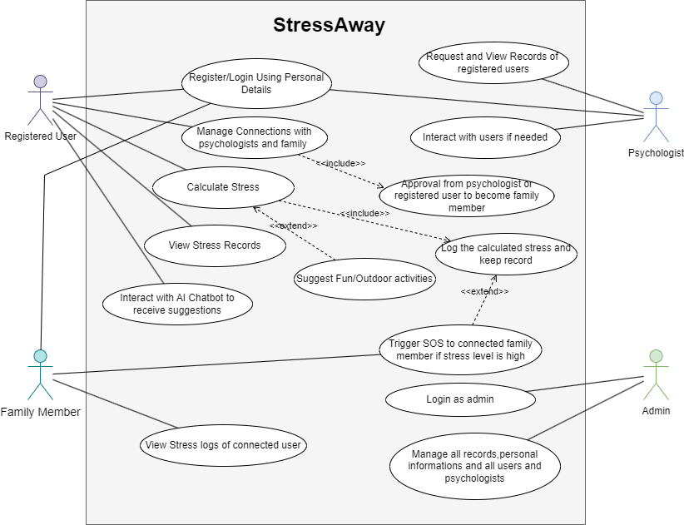
Figure 4: Use Case Diagram

Use Cases Description

1.2.1. Register/Login Using Personal Details
Goal:
Allow users to create an account or login into our system.
Primary Actor:
Users, Psychologists.
Preconditions:
User should have valid personal information (email, password, etc.).
Postconditions:
User is logged in or user account is created.
Main Flow
- User enters personal information.
- System validates the information.
- System creates account or authenticates the user.
- System redirects user to dashboard.
Alternate Flows:
A1: Invalid credentials → System shows error.
Exceptions:
E1: Duplicate email during registration.
E2: Server error.

1.2.2. Manage Connections with Psychologists and Family
Goal:
This will enable a registered user to add the Psychologists or the family to his/her support circle.
Primary Actor:
Registered User
Secondary Actor:
Psychologist, Family Member
Preconditions:
To log in, User should be logged in.
Postconditions:
Selected psychologist or family member is connected after approval.
Main Flow:
- User requests connection with psychologist or family member.
- System sends approval request.
- Psychologist/Family Member approves the request.
- Connection is established.
Alternate Flows:
A1: Psychologist/family declines the request.
Exceptions:
E1: Already connected.
E2: Invalid approval.

1.2.3. Approval to Become Family Member (Included Use Case)
Goal:
Accept or reject an addition request of a registered user.
Actor:
Family Member / Psychologist
Flow:
- Actor receives connection request.
- Actor reviews and selects approve or reject.
- System updates connection status.

1.2.4. Calculate Stress
Goal:
Analyze user’s facial expression, speech, and wellness inputs to generate a stress score.
Primary Actor:
Registered User
Preconditions:
User is logged in.
Postconditions:
Stress score is calculated.
Main Flow:
- User initiates stress calculation.
- System collects required inputs.
- System applies AI model to compute stress score.
- System displays result.
Exceptions:
E1: Camera/mic unavailable.
E2: Model fails to compute.

1.2.5. Log the Calculated Stress and Keep Record (Included Use Case)
Goal:
Automatically save the computed stress score in the system.
Flow:
- After stress is calculated, system logs the score.
- System timestamps and stores the record.

1.2.6. View Stress Records
Goal:
Allow registered users to view their stress history.
Actor:
Registered User
Preconditions:
At least one stress record exists.
Postconditions:
Stress logs are displayed.
Main Flow:
- User opens stress history page.
- System retrieves and displays records.

1.2.7. Suggest Fun/Outdoor Activities (Included Use Case)
Goal:
Provide personalized suggestions based on stress level.
Actor:
StressAway System
Flow:
- System checks calculated stress.
- System determines activity suggestions.
- Suggestions displayed to the user.

1.2.8. Trigger SOS if Stress Level is High (Extended Use Case)
Goal:
Send emergency alerts to connected family members when stress is critically high.
Primary Actor:
StressAway System
Secondary Actor:
Family Member
Preconditions:
User has connected family members.
Postconditions:
Family is notified through SOS alert.
Main Flow:
- System detects high stress level.
- System prepares emergency SOS.
- SOS is sent to family member.
Exceptions:
E1: No family members connected.
E2: Network failure while sending SOS.

1.2.9. View Stress Logs of Connected User
Goal:
Allow family members to monitor stress history of linked users.
Actor:
Family Member
Preconditions:
Connection must be approved.
Main Flow:
- Family member opens connected user logs.
- System retrieves and displays records.

1.2.10. Interact with AI Chatbot to Receive Suggestions
Goal:
Provide a wellness AI chatbot to communicate.
Actor:
Registered User
Flow:
- User opens chatbot.
- User types or speaks query.
- Chatbot processes input.
- System gives actionable suggestions.

1.2.11. Request and View Records of Registered Users
Goal:
Allow psychologists to review stress history of connected users.
Actor:
Psychologist
Preconditions:
Psychologist must be connected with the user.
Postconditions:
User records are displayed.
Flow:
- Psychologist selects a connected user.
- System retrieves user logs.
- System displays mental health history.

1.2.12. Interact with Users if Needed
Goal:
Enable psychologists to communicate with registered users for guidance.
Actor:
Psychologist
Flow:
- Psychologist opens communication panel.
- Psychologist sends message.
- User receives and replies.

1.2.13. Manage All Records, Personal Information, Users, and Psychologists
Goal:
Allow admin to manage overall system data and user accounts.
Actor:
Admin
Main Flow:
- Admin logs in.
- Admin views the list of users/psychologists.
- Admin edits, updates, or deletes data and System confirms changes.
Exceptions:
E1: Unauthorized access attempt.
E2: Record not found.

Chapter 4

System Design
Chapter 4: System Design
This chapter presents the full system design of the StressAway platform which further elaborates the process through which the mental wellness solution offered is designed, structured and implemented. It defines the architecture, modules of the system, flow of data and interaction between different users, psychologists and administrators and AI-driven services. This design is geared towards ensuring that it is scaled, secure, usable, and does efficient stress-related data processing, both questionnaire-based assessments and emotion-recognition assessments. Additionally, the chapter discusses how dashboards, SOS mechanisms, family relations, and AI chatbot are integrated to form an ecosystem of dynamic mental spaces. On the whole it gives a detailed picture of how all the subsystems work and systems are set up to achieve reliability, scalability and efficient user experience to guarantee effective stress monitoring, analysis and management.

Architecture Diagram
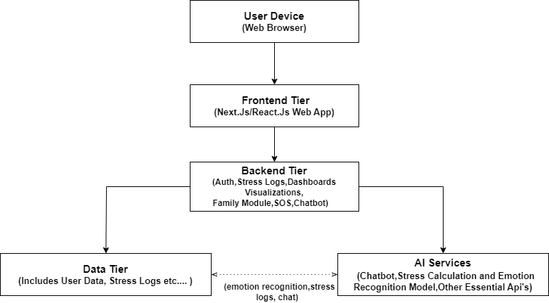

Figure 5: Architecture Diagram

The StressAway platform uses a Hybrid Architecture composed of following:
- Three-Tier (3-Tier) Web Architecture
StressAway follows the 3-tier architecture pattern:
Tier 1: Presentation Tier (Frontend):
- Web frontend (Next.Js)
- Dashboards, forms, chat UI
Tier 2: Backend/Logic Tier (Backend):
- Backend API (Node.js).
- Authentication, stress scoring, alerts, connections, role-based dashboards.
Tier 3: Data Tier (Database):
- Supabase (users, stress logs, psychologists/family connections data, questionnaire data).
This makes your architecture Three-Tier Web Architecture, which is the standard for modern web systems.
- Modular / Microservices-Inspired Architecture
Although not full microservices, the system has modular microservice-like components connected to database and backend tiers, such as:
- Emotion recognition AI service
- Chatbot AI service
- Notification/SOS service
- Stress calculation service
This style is best described as:
“Microservices-Inspired Modular Architecture inside a 3-Tier Structure”
- Service-Oriented and RESTful API design principles
AI services, questionnaire service, dashboards service are separated into modules.
1.RESTful Architecture:
Backend exposes REST APIs for:
- stress logs
- questionnaires
- emotional analysis
- family connections
- SOS alerts
2.Client–Server Architecture:
Frontend and backend communicate through HTTP APIs.

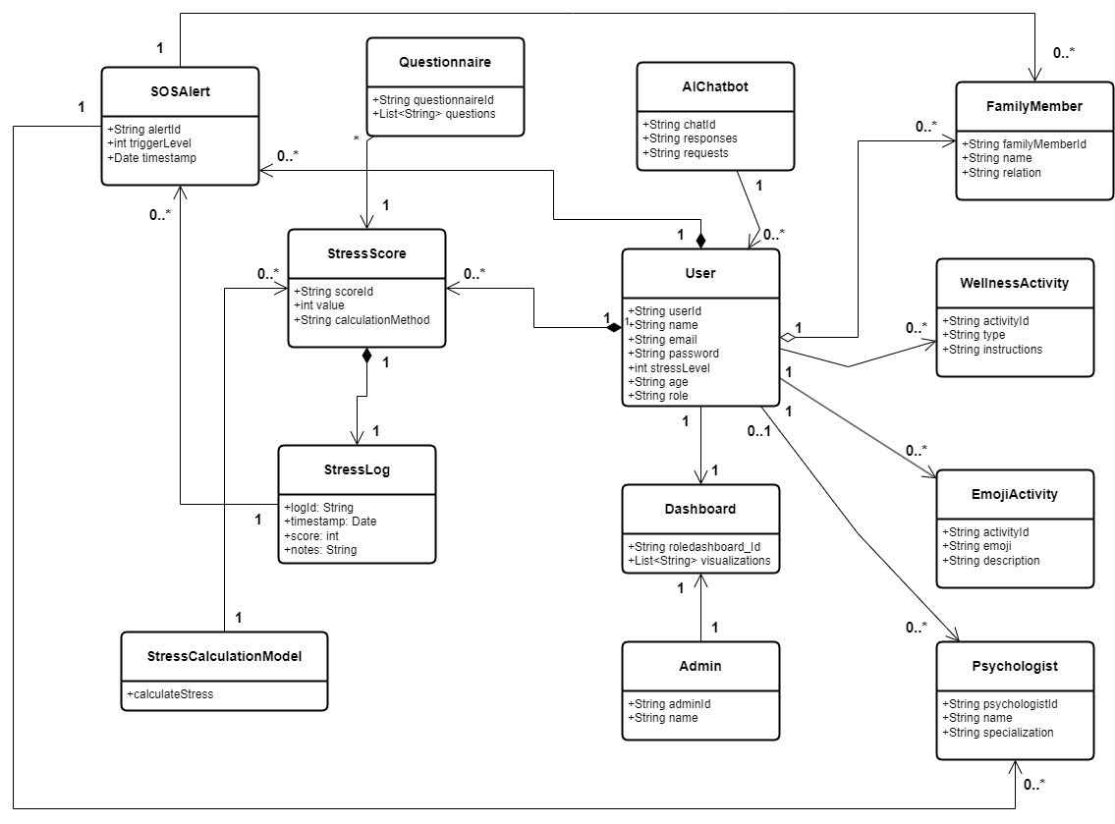
Domain Model
Figure 6: Domain Model Diagram

Entity Relationship Diagram with data dictionary

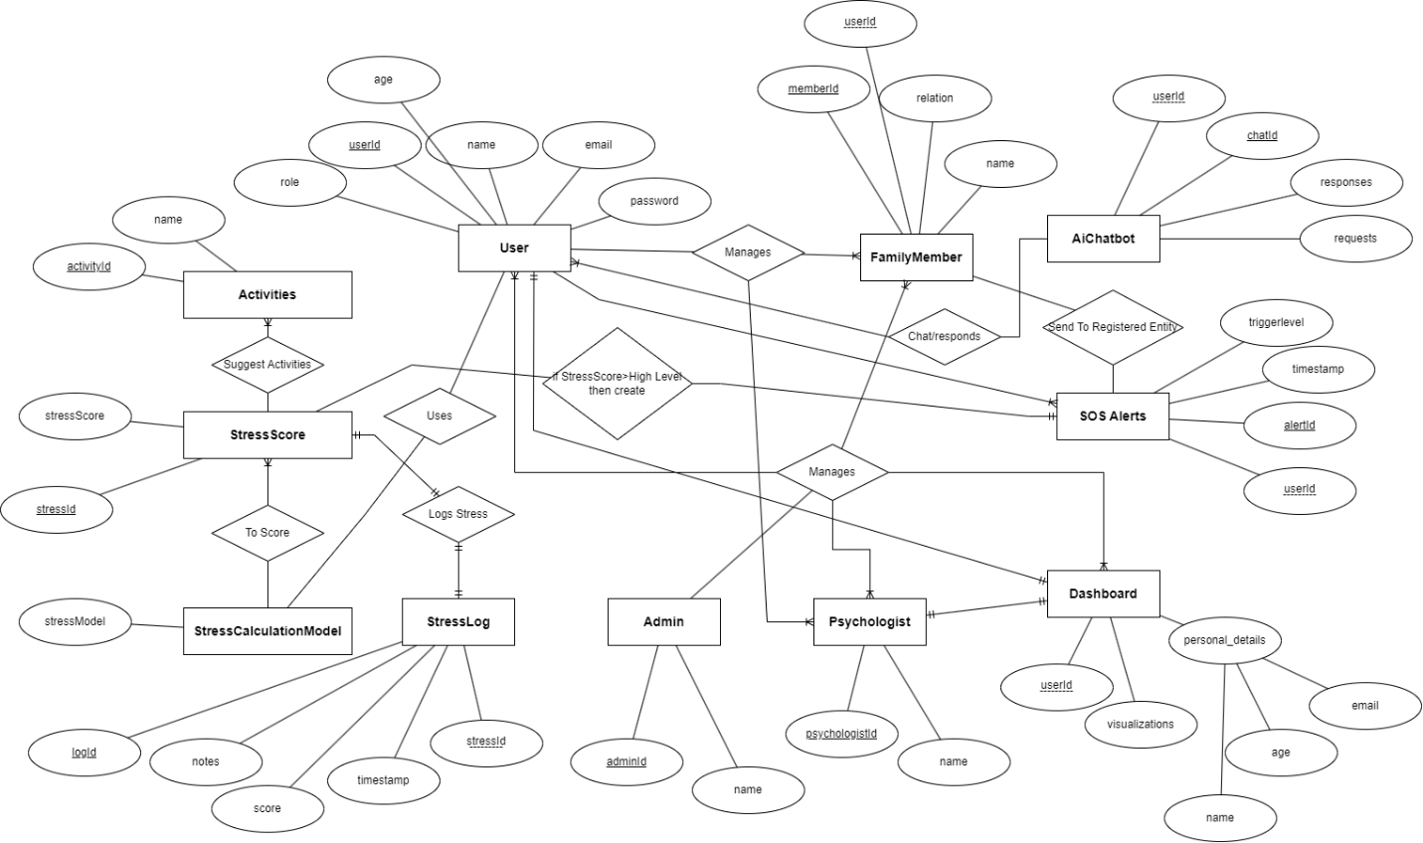
4.3.1 Diagram
Figure 7: ERD Diagram

4.3.2 Data Dictionary for StressAway ERD
1. User Entity (Table)
Table 5: Data Dictionary For ERD Diagram Tables Separately
Attribute Name | Data Type | Key Type | Description
userId | INT | PK | Unique identifier for the user.
name | String | - | User's full name.
email | String | - | User's email address (should be unique).
password | String | - | Hashed password for user authentication.
age | INT | - | User's age.
role | String | - | User's role in the system (e.g., standard, patient).
2. Activities Entity (Table)
Attribute Name | Data Type | Key Type | Description
activityId | INT | PK | Unique identifier for the wellness activity.
name | String | - | Name of the activity (e.g., "Meditation", "Walking").

3. Stress Score Entity (Table)
Attribute Name | Data Type | Key Type | Description
stressId | INT | PK | Unique identifier for a specific stress score record.
stressScore | INT | - | The calculated stress level (e.g., 1 to 10).

4. Stress Calculation Model Entity (Table)
Attribute Name | Data Type | Key Type | Description
stressModel | INT | PK | Unique identifier for the calculation model used.

5. Stress Log Entity (Table)
Attribute Name | Data Type | Key Type | Description
logId | INT | PK | Unique identifier for a single log entry.
Score | INT | - | The stress score recorded in this log entry.
Timestamp | DateTime | - | Date and time the log entry was created.
Notes | String | - | Any additional notes or context for the log entry.
stressId | INT | FK | Links the log entry back to the Stress Score it is a detail of.

6. SOS Alerts Entity (Table)
Attribute Name | Data Type | Key Type | Description
alertId | String/INT | PK | Unique identifier for an SOS alert.
Timestamp | DateTime | - | Date and time the alert was triggered.
triggerLevel | INT | - | The stress level at which the alert was triggered.
userId | String/INT | FK | Links the alert to the User who triggered it.

7. AI Chatbot Entity (Table)
Attribute Name | Data Type | Key Type | Description
chatId | String/INT | PK | Unique identifier for a chat session.
Responses | String | - | A record of the chatbot's responses.
Requests | String | - | A record of the user's requests/inputs.
userId | String/INT | FK | Links the chat session to the User who participated.

8. Family Member Entity (Table)
Attribute Name | Data Type | Key Type | Description
memberId | String/INT | PK | Unique identifier for the family member.
Name | String | - | Name of the family member.
Relation | String | - | Relationship to the user (e.g., "Parent", "Sibling").
userId | String/INT | FK | Links the family member to the primary User.

9. Dashboard Entity (Table)
Attribute Name | Data Type | Key Type | Description
userId | String/INT | PK, FK | The User ID serves as the identifier for the Dashboard (1-to-1 relationship with User).
Name | String | - | Name/title of the dashboard view.
visualizations | String | - | Configuration details for the data visualizations.
Email | String | - | Email listed on the dashboard (if separate from user email).
Age | INT | - | Age displayed on the dashboard (if separate from user age).

10. Psychologist Entity (Table)
Attribute Name | Data Type | Key Type | Description
psychologistId | String/INT | PK | Unique identifier for the psychologist.
Name | String | - | Psychologist's full name.

11. Admin Entity (Table)
Attribute Name | Data Type | Key Type | Description
adminId | String/INT | PK | Unique identifier for the administrator.
Name | String | - | Administrator's name.

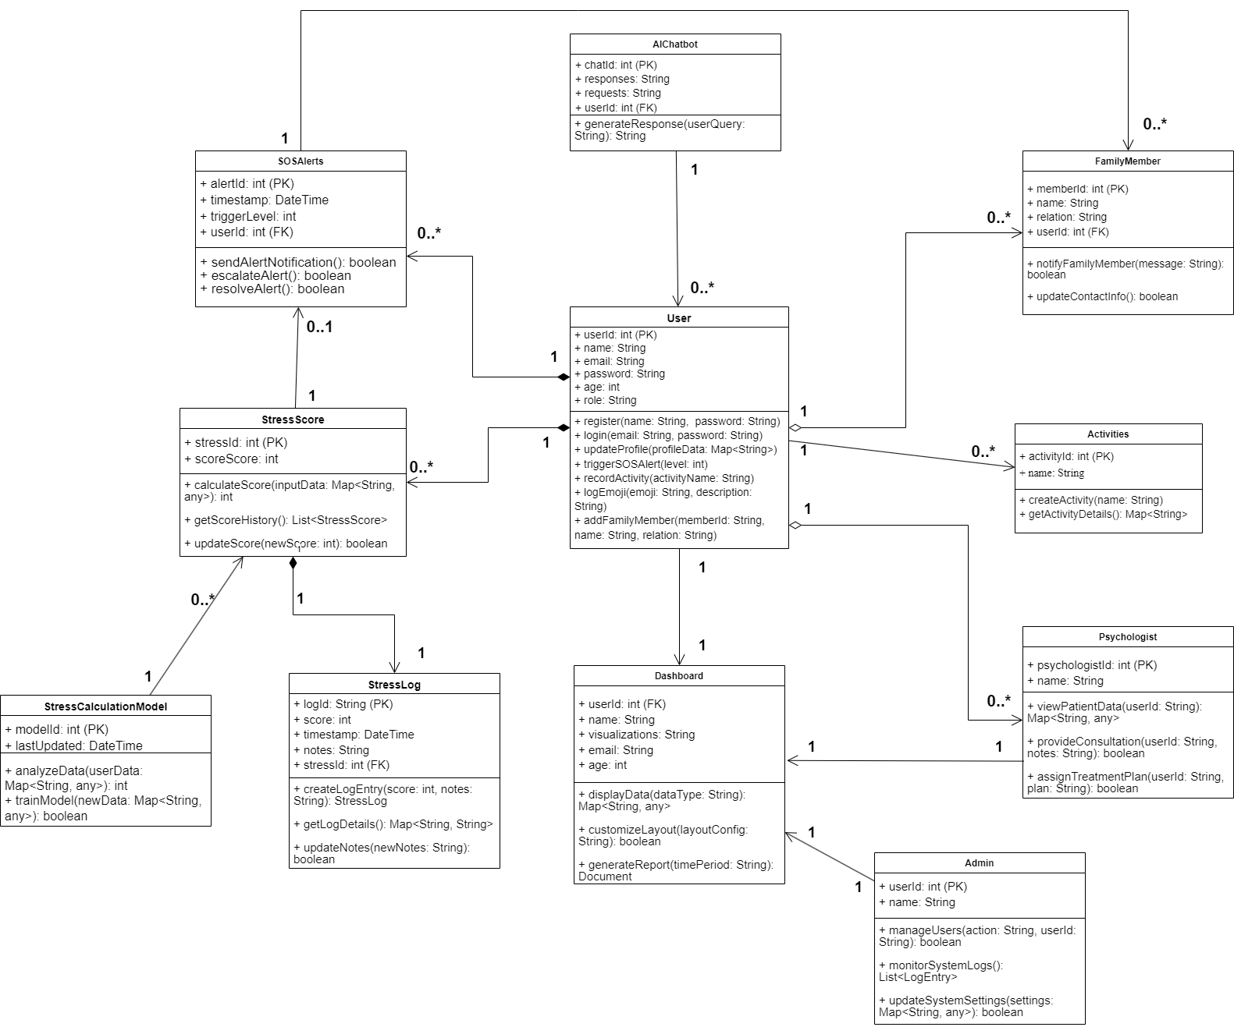
Class Diagram
Figure 8: Class Diagram

Sequence Diagram
I will divide sequence diagrams of whole system into three diagrams as system is too big and we can’t make one diagram as it would be too big so, following are diagrams one by one:

4.5.1. User Flow (Registration, Login, View Dashboard)
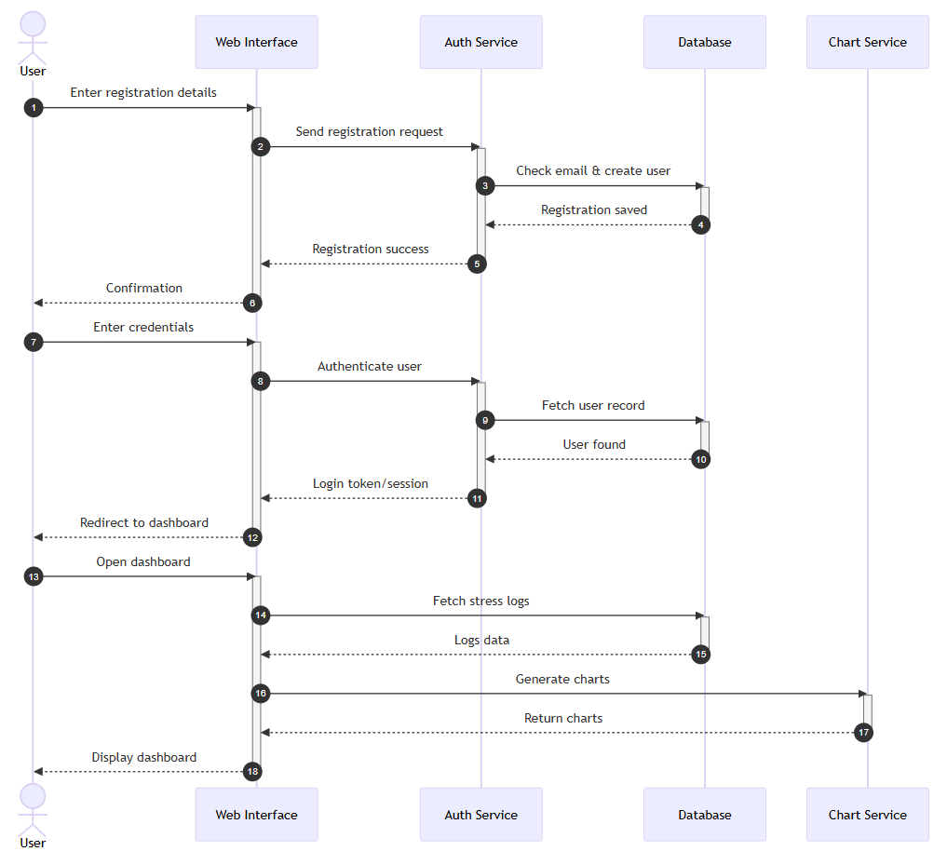
Figure 9: Sequence Diagram 1

4.5.2. Stress Score Calculation Flow (Questionnaire, Face Analysis, SOS)
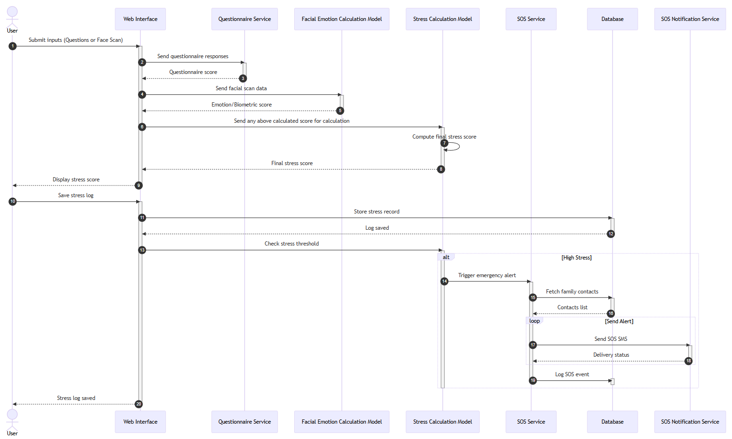
Figure 10: Sequence Diagram 2

4.5.3. Psychologist Connection and Ai Chatbot Interaction
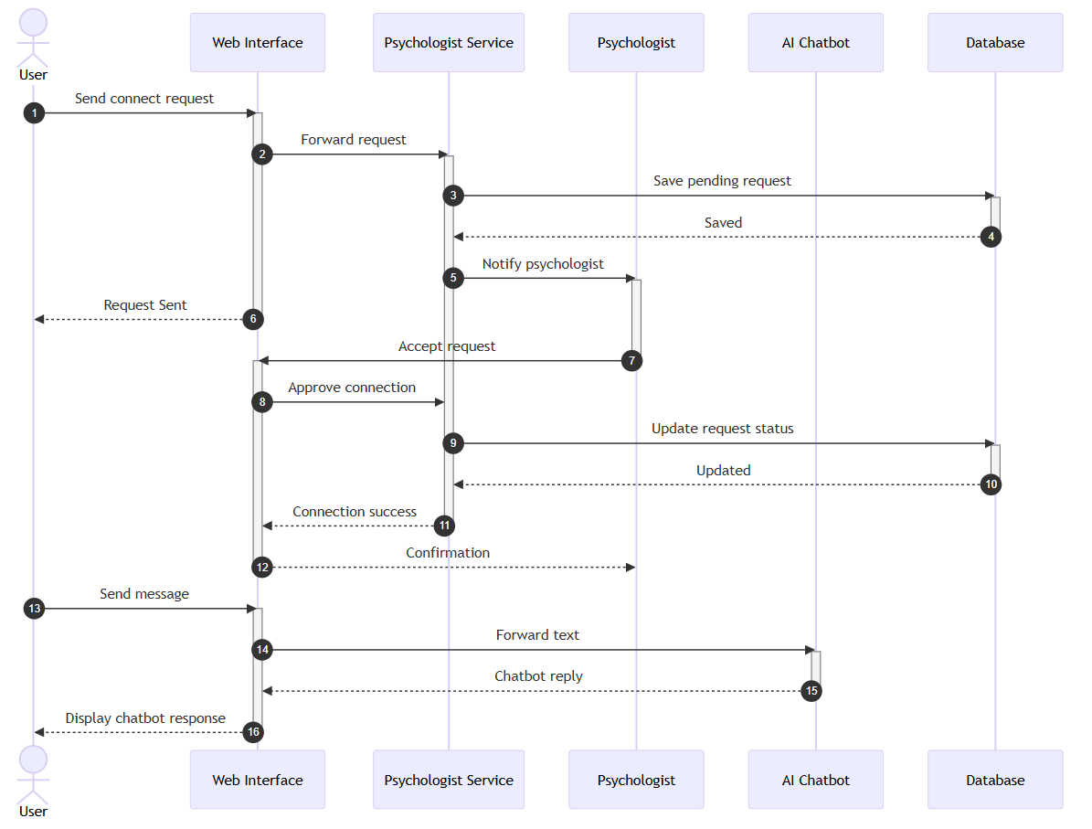
Figure 11: Sequence Diagram 3

Operation contracts

4.6.1. User Registration & Authentication

4.6.1.1 Register User
Responsibility:
Create a new user account with secure credentials.
Preconditions:
- User is not already registered with the same email.
Postconditions:
- A new User record is created.
- User profile initialized with default settings and empty stress logs.
- Family tree module initialized for the user.
Input:
- Name, Email, Password, Age, Gender
Output:
- Confirmation of registration.
Exceptions:
- Email Already Exists Exception.
- Invalid Input Exception.

4.6.1.2 Login User
Responsibility:
Authenticate user with email and password.
Preconditions:
- User must be registered.
- User account must be active.
Postconditions:
- User session created.
- Last login time updated.
Input:
- Email, Password
Output:
- Login Success / Failure message.
Exceptions:
- Authentication Failed Exception
- Account Blocked Exception

4.6.2. Stress Score Calculation & Logging

4.6.2.1 Calculate Stress Score
Responsibility:
Calculate stress score based on questionnaire answers and face expression analysis.
Preconditions:
- User must be authenticated.
- Questionnaire must be fully attempted OR face scan successfully captured.
Postconditions:
- Stress score computed and returned to the user.
Input:
- Questionnaire responses
- Facial analysis data (optional)
Output:
- Stress score (numeric)
Exceptions:
- Incomplete Questionnaire Exception
- Face Scan Error Exception

4.6.2.2 Create Stress Log
Responsibility:
Save a newly calculated stress score as a log entry.
Preconditions:
- User must be authenticated.
- Stress score must have been generated.
Postconditions:
- New stress log created and added to the user's log history.
- Dashboard charts updated automatically.
- If score is above threshold then trigger SOS routine.
Input:
- Stress score
- Timestamp
- Optional notes
Output:
- Confirmation of log creation.
Exceptions:
- Invalid Stress Score Exception
- Database Write Exception

4.6.3. Dashboards

4.6.3.1 View User Dashboard
Responsibility:
Display user's stress levels, trends, and visualizations.
Preconditions:
- User must be authenticated.
Postconditions:
- System retrieves stress logs and generates time-series charts.
Input:
- User ID
Output:
- Dashboard with charts and recommendations.
Exceptions:
- No Logs Found Exception

4.6.3.2 View Psychologist Dashboard
Responsibility:
Allow psychologists to view user details, history, and improvements.
Preconditions:
- Psychologist must be authenticated.
- User must have accepted connection request.
Postconditions:
- System retrieves user stats and generates analytics.
Input:
- Psychologist ID
- User ID
Output:
- User’s stress analytics dashboard.
Exceptions:
- Unauthorized Access Exception.
- Connection Not Found Exception.

4.6.3.3 View Admin Dashboard
Responsibility:
Allow admins to view all system statistics.
Preconditions:
- Admin must be authenticated.
Postconditions:
- Admin sees user count, psychologists, logs, and system analytics.
Input:
- Admin ID
Output:
- System status dashboard.
Exceptions:
- Unauthorized Access Exception

4.6.4. Chatbot Operations

4.6.4.1 Chatbot Interaction
Responsibility:
Provide real-time suggestions based on stress level and emotional keywords.
Preconditions:
- User must be authenticated.
Postconditions:
- Chatbot generates text/audio-based suggestions.
- Stores conversation context for personalization.
Input:
- Message from user
- Current stress score (optional)
Output:
- Chatbot response message
Exceptions:
- NLP Processing Exception

4.6.5. Emoji Activities & Suggestions

4.6.5.1 Select Emoji Activity
Responsibility:
Allow user to select and perform fun emoji based stress relief activities.
Preconditions:
- User must be authenticated.
Postconditions:
- Activity recorded.
- Stress level recommendations updated.
Input:
- Selected emoji/activity ID
Output:
- Activity confirmation + recommended follow-up activity.
Exceptions:
- Activity Not Found Exception

4.6.5.2 Get Wellness Suggestions
Responsibility:
Suggest fitness, breathing, or relaxation activities.
Preconditions:
- User must be login/authenticated.
Postconditions:
- System provides personalized suggestions.
Input:
- Stress score
Output:
- List of suggestions
Exceptions:
- No Suggestions Available Exception

4.6.6. Psychologist Connection Module

4.6.6.1 Send Connection Request To Psychologist
Responsibility:
User sends a request to connect with a psychologist.
Preconditions:
- User must be authenticated.
Postconditions:
- A new connection request created.
Input:
- User ID
- Psychologist ID
Output:
- Request Sent confirmation
Exceptions:
- Already Connected Exception
- Psychologist Not Found Exception

4.6.6.2 Accept Connection Request
Responsibility:
Psychologist accepts user connection request.
Preconditions:
- Psychologist must be authenticated.
- Pending request must exist.
Postconditions:
- User-Psychologist connection established.
Input:
- Request ID
Output:
- Connection Success message
Exceptions:
- Request Not Found Exception

4.6.7. Family Tree & SOS Module

4.6.7.1 Add Family Member
Responsibility:
Add a family member profile to user’s family tree.
Preconditions:
- User must be login/authenticated.
Postconditions:
- Family member added.
Input:
- User ID and User Name.
- Relation
Output:
- Member Added confirmation.
Exceptions:
- Invalid User Exception.

4.6.7.2 Send SOS Alert
Responsibility:
Send emergency alert to family when stress exceeds threshold.
Preconditions:
- Stress log created with high stress score.
- Family members exist.
Postconditions:
- SOS message sent to registered family contacts.
- System logs SOS event.
Input:
- User ID
- Stress score
Output:
- SOS Alert Sent confirmation.
Exceptions:
- No Family Members Found Exception
- SMS Send Failure Exception

4.6.8. Admin Operations

4.6.8.1 Manage Users
Responsibility:
Admin can activate/deactivate user accounts.
Preconditions:
- Admin must be authenticated.
Postconditions:
- User account status updated.
Input:
- User ID
- Action (activate / deactivate)
Output:
- Account Updated message
Exceptions:
- User Not Found Exception

4.6.8.2 Manage Psychologists
Responsibility:
Admin adds, approves, or removes psychologists.
Preconditions:
- Admin must be authenticated.
Postconditions:
- Psychologist directory updated.
Input:
- Psychologist details or ID.
Output:
- Operation confirmation.
Exceptions:
- Invalid Credentials Exception.

Activity Diagram
I would also create 3 activity diagrams for StressAway as system is large and we can’t manage everything in one diagram so, following are 3 activity diagrams:

4.7.1. User Registration, Login & Dashboard View
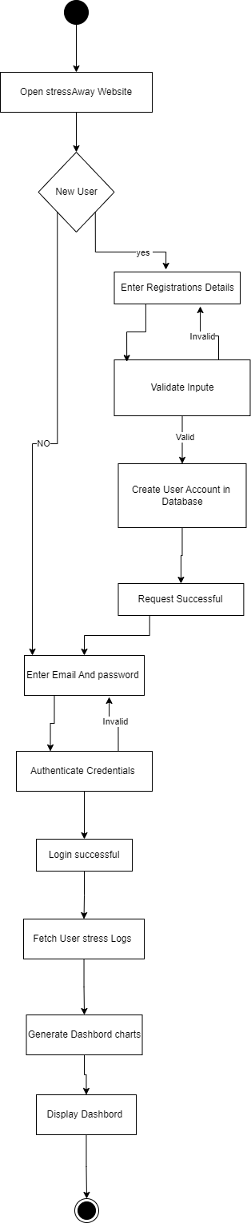

Figure 12: Activity Diagram 1

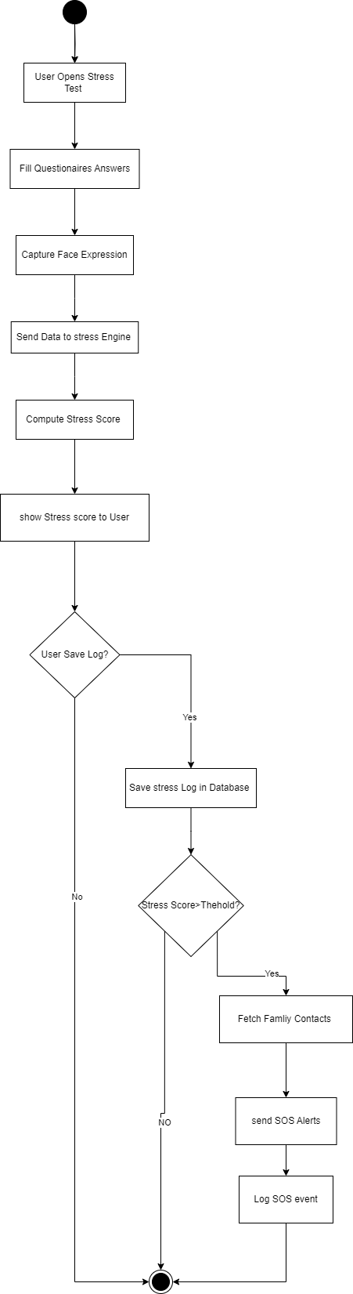
4.7.2. Stress Calculation, Logging & SOS Alert
Figure 13: Activity Diagram 2

4.7.3. Psychologist Connection & AI Chatbot
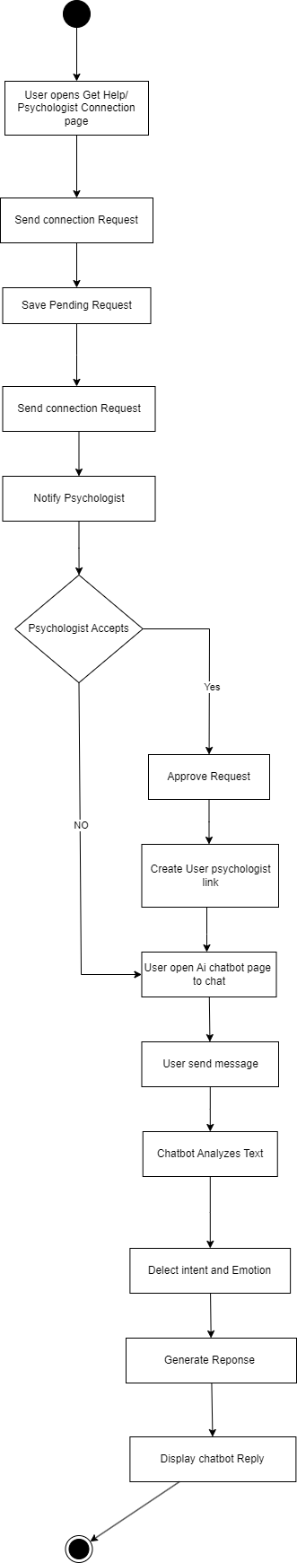

Figure 14: Activity Diagram 3

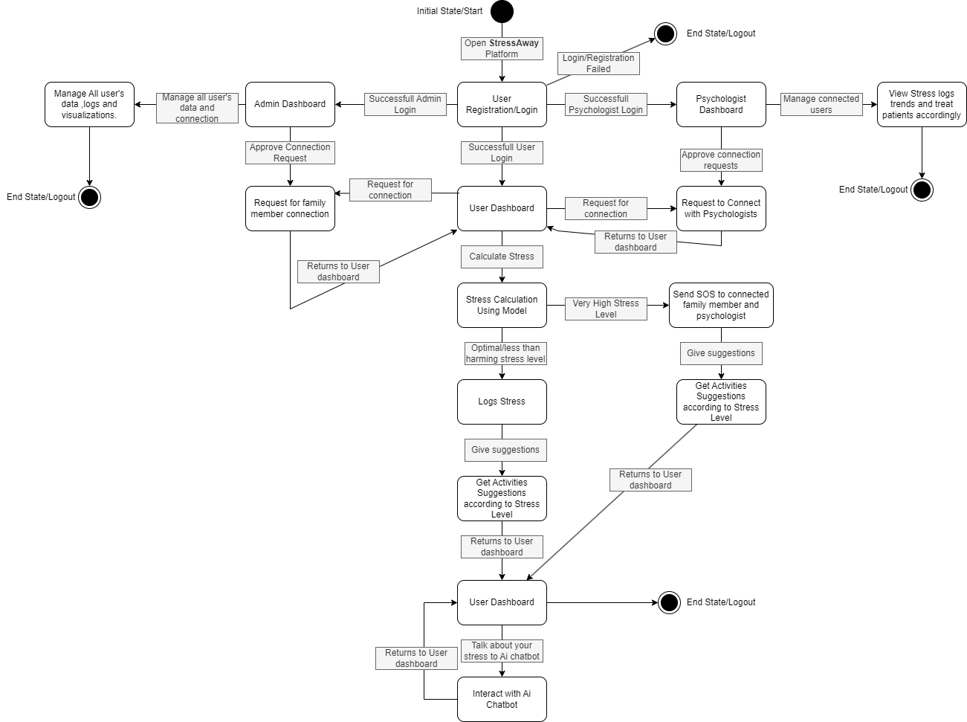
State Transition Diagram

Figure 15: State Transition Diagram

Component Diagram
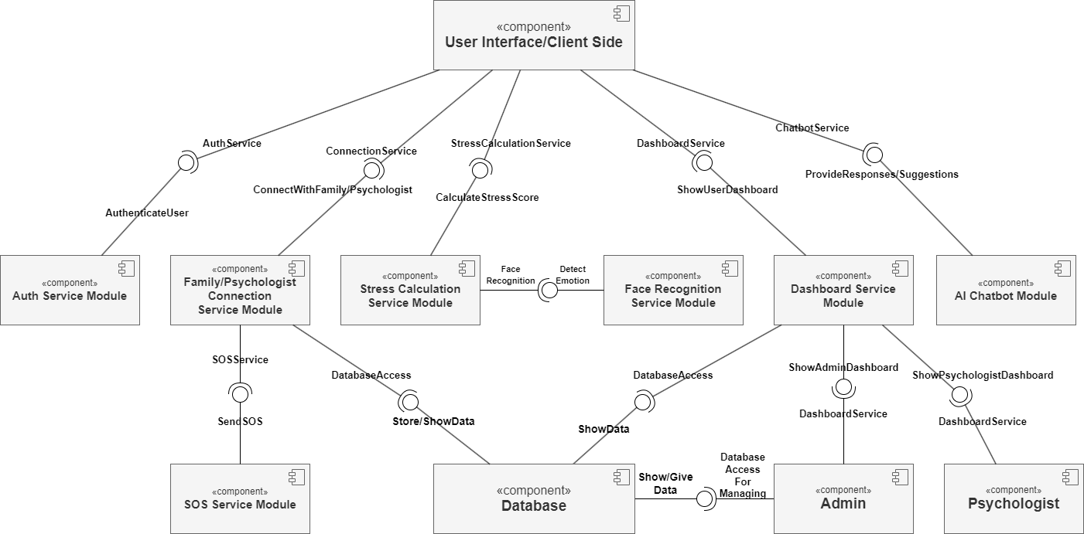
Figure 16: Component Diagram

Deployment Diagram
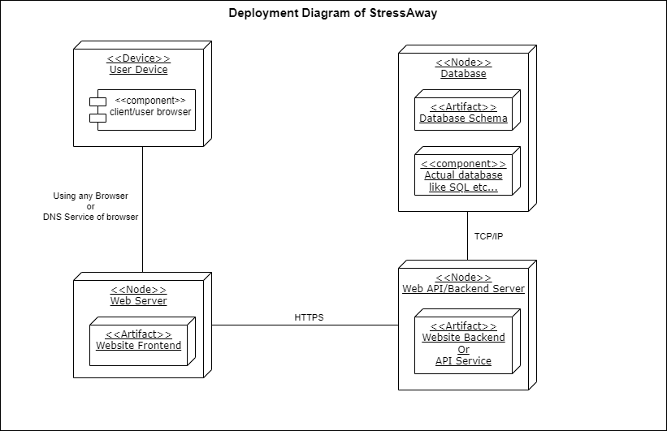
Figure 17: Deployment Diagram

Data Flow diagram

4.11.1. Data Flow Diagram Level-0
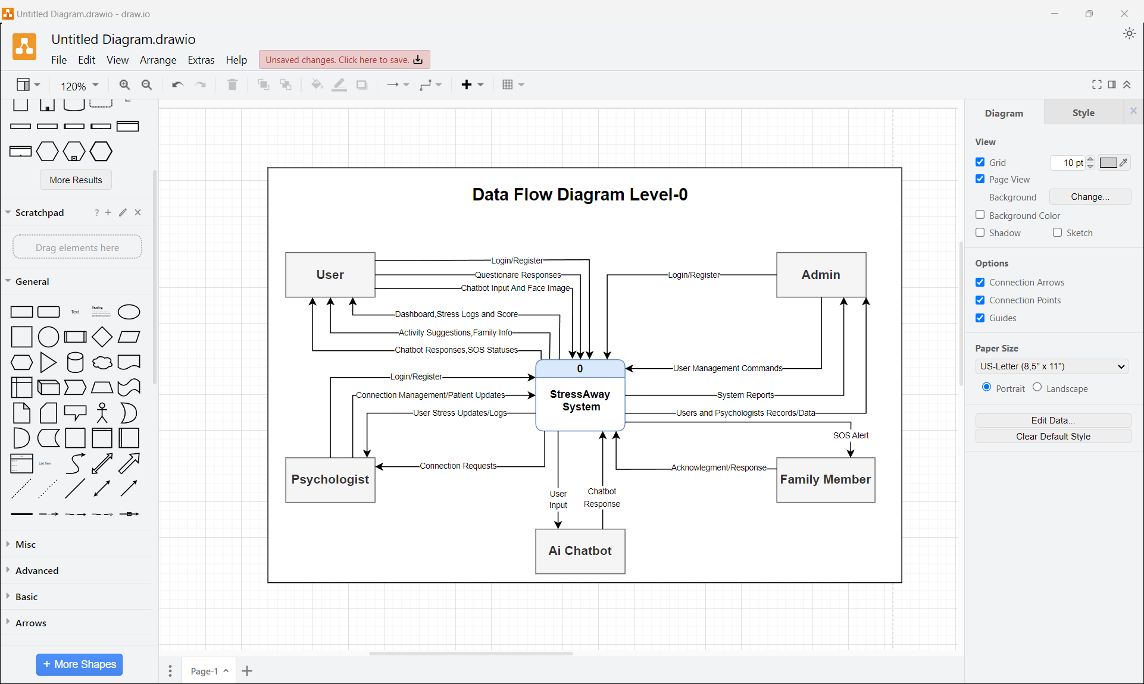
Figure 18: Data Flow Diagram Level 0

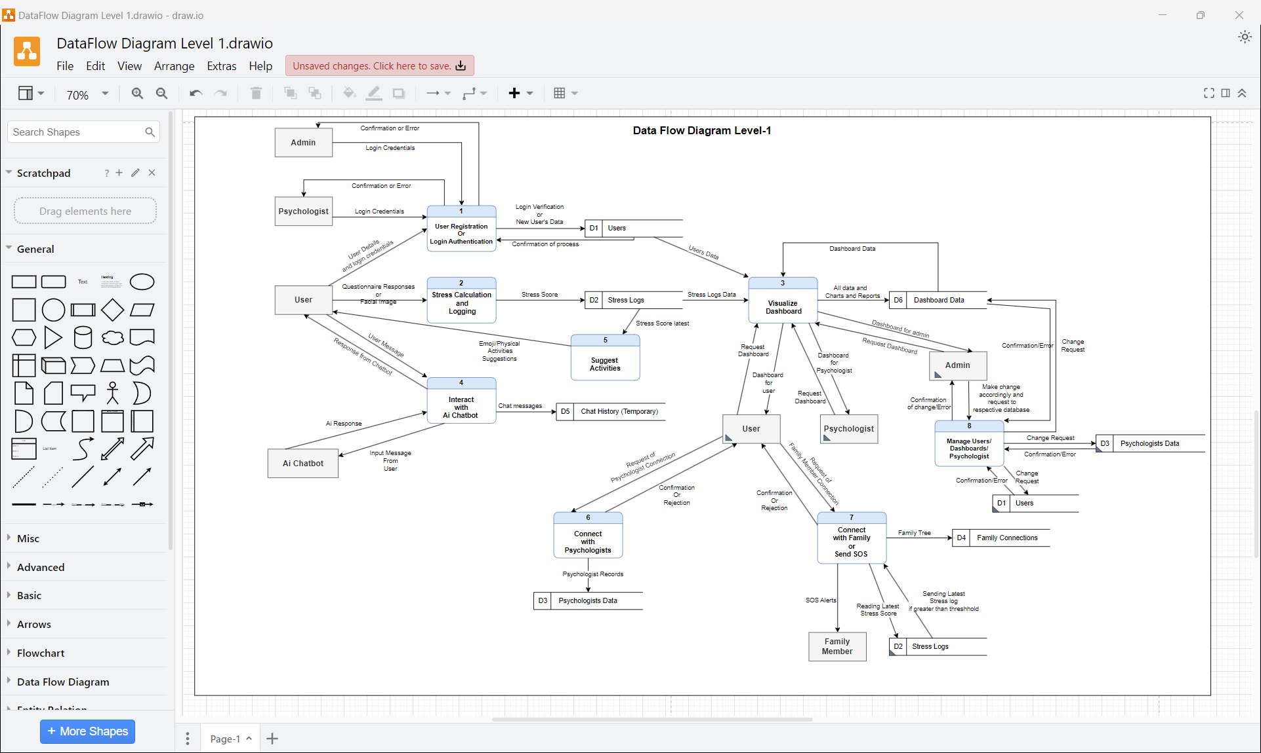
4.12.2. Data Flow Diagram Level-1

Figure 19: Data Flow Diagram Level 1

Chapter 5

Implementation

Chapter 5: Implementation
This chapter gives the pragmatic part in the use of the StressAway system. It touches upon high-level implementation process (such as logical flow of the system), components and libraries used, deployment environment, tools, techniques, style of code and version control. Specifically, it talks about the primary control flows, integration of the parts of the system (AI chatbot and emotion recognition service), and the version management possibility to have a strong, scalable and maintainable system. The aim of this chapter is to provide a closer look into the development and implementation of this system to ensure that it must work efficiently, be user-friendly and maintainable.

Important Flow Control/Pseudo codes
The implementation of StressAway is based on great flow control mechanisms to handle user interactions, stress score calculations, dashboard updates, AI chatbot responses, and alert notifications. Below is pseudo code showing some of the workflow from whole system:

5.1.1. User Registration & Login
BEGIN
Appear to demand registration/Login.
IF new user THEN
Collect personal details
insert user in database.
ELSE
Authenticate user credentials
ENDIF
END

5.1.2. Stress Score Calculation & Logging
BEGIN
Display questionnaire to user
Collect answers
Calculate stress_score using weighted formula
Store stress SCORE in database
END
OR
BEGIN
Detect emotions via face recognition
Store stress score and emotion data in database
END

5.1.3. Dashboard Update
BEGIN
Get user stress history.
Generate charts
Display personalized dashboard
when user is a psychologist/admin THEN.
Display user data.
ENDIF
END

5.1.4. AI Chatbot Interaction
BEGIN
User sends message
AI processes input
Suggest stress management tips or activities
Log chat interaction
END

5.1.5. Emergency Alert (SOS)
BEGIN
IF stress score > THEN ends.
Send SOS message to SOS contacts.
Recommend psychologist connection
ENDIF
END

Components, Libraries, Web Services and stubs
StressAway uses multiple components and services to deliver an integrated wellness platform:
- Frontend: Next.Js , Chart.js for data visualizations.
- Backend: Node.js with Nest.Js framework, AI chatbot with Gemini API.
- Database: Supabase for storing user profiles, stress logs, chat history, and family connections.
- Libraries: TensorFlow.js for emotion recognition, bcrypt/other tech for password hashing, JWT for authentication.
- Web Services: In built notification API for SOS alerts.
- Stubs: Used to simulate psychologist’s modules and AI responses during early development/testing phases.

Deployment Environment
- Server: Vercel/Render for running Node.js backend.
- Database: Supabase database for 24/7 availability and security.
- Web Hosting: Next.Js frontend hosted on Vercel.
- Security: HTTPS enabled, JWT-based authentication.
- Environment Configuration: Separate development, testing and production environments with environment variables for API keys and credentials.

Tools and Techniques
The development of StressAway leveraged modern tools and techniques to ensure quality and maintainability:
- IDE: VS Code.
- Version Control: Git with GitHub.
- Tools: Postman to test the APIs.
- Design: Figma to use when doing a UI/UX mockup and wireframes.
- Agile Practices: Iterative development and planning, continuous feedback.

Best Practices / Coding Standards
In order to be sustainable and readable the following best practices are embraced:
- Use meaningful variable and function names.
- Follow consistent formatting (Prettier for JavaScript).
- Modular design with separation of concerns.
- Reusable Next.Js components for UI elements.
- Secure coding practices like implementing input validation, encryption of passwords.
- Commenting out all major functions and APIs for proper identification even after development.

Version Control
Git will be used for version control. Key practices included:
- Creating separate branches for testing, development and main.
- Check out the code, before it is included in the main branch.
- Marking stable releases with version numbers.
- Maintaining a clear commit history with clear explanation messages.

Chapter 6

Testing and Evaluation

Chapter 6: Testing and Evaluation
In this chapter, the testing phase and methods used to test the StressAway system to make sure that the system is correct, reliable and performs well are described. Both non-functional and functional requirements were tested using different testing techniques, such as use case testing, equivalence partitioning, boundary value analysis, data flow testing, unit testing, integration testing, performance and stress testing. This phase was aimed to find the mistakes, maintaining the smooth functioning of the system, and confirming the functionality of all modules like authentication, stress calculation, dashboards, SOS alert system, user connection features and AI features under various conditions. Moreover, a lot of testing on responsiveness was done so that there is a smooth performance on mobile phones, tablets and desktop devices. Security testing was as well conducted to safeguard sensitive mental health information. All in all, the system has been tested in normal, boundary and extreme conditions and has been confirmed to be reliable and to offer a smooth user experience.

Use Case Testing
The system was tested with use case testing to ensure that the system is in line with real user scenarios. All the key players (User, Psychologist, Admin) have been tested by the workflows. As an example, user registration, entering, stress measurement, chatbot communication, and SOS notifications activation were performed in stages to guarantee desired results. Similarly, psychologist dashboards and admin capabilities were also evaluated in terms of accuracy and accessibility. This testing was necessary to make sure that the user interactions were all in line with the specified use-cases and that the system would not act out in the real-life scenarios.
Test Cases:
Test Case ID | Actor | Use Case | Test Scenario | Expected Result | Status
UC-01 | User | Register Account | Enter valid user details | Account successfully created | Pass
UC-02 | User | Login | Enter correct credentials | Redirect to user dashboard | Pass
UC-03 | User | Fill Questionnaire | Submit all answers | Stress score generated (0–100) | Pass
UC-04 | User | Facial Detection | Capture face via webcam | Emotion detected using trained model | Pass
UC-05 | User | Dashboard View | Open dashboard | Charts show stress trends | Pass
UC-06 | User | Chatbot | Send input | Relevant response generated | Pass
UC-07 | User | SOS Alert | Trigger under high stress | Alert sent to connections | Pass
UC-08 | Psychologist | View Reports | Access assigned users | Stress reports displayed | Pass
UC-09 | Admin | Manage System | Access admin panel | System data accessible | Pass
UC-10 | User | Activities | Select emoji/mood | Activity suggested and started successfully | Pass
UC-11 | User | Manage Family or Psychologist’s Connections | Send request and wait for acceptance or rejection | Successful connection or rejected | Pass
UC-12 | User | Manage SOS contacts | Delete or add SOS contacts | Successful SOS contacts management | Pass
UC-13 | Psychologist | Manage SOS contacts and requests | View and accept or delete requests | Successful management | Pass

Equivalence partitioning
The input data was partitioned into valid and invalid data using equivalence partitioning to minimize the test cases and still cover all data. As an example, in the login module, the valid inputs were properly formatted emails and strong passwords and invalid inputs were blank fields, invalid format, and wrong credentials. Equally, the inputs of the stress questionnaires were classified into valid ranges of responses and invalid or missing responses. This method was effective in detecting input validation problems without trying all possible values.
Test Cases:
Module | Input Type | Valid Class | Invalid Class | Expected Result | Status
Registration | Email | Correct format | Invalid/missing | Accept / Reject | Pass
Login | Credentials | Correct input | Wrong input | Login / Error | Pass
Questionnaire | Answers | All answered | Missing answers | Score / Error | Pass
Facial Module | Face Input | Clear face | No face/blur | Detect / Warning | Pass
Chatbot | Text | Valid message | Empty input | Response / Error | Pass
SOS | Stress Level | Above threshold | Below threshold | Trigger / No action | Pass

Boundary value analysis
The edge cases that are likely to have errors were tested using the technique of boundary value analysis. As an example, when calculating stress scores (range 0-100), 0, 1, 99 and 100 were tested to ensure that the system worked as intended. Fields like password length, questionnaire limits, and API response sizes were also tested to their limits (minimum and maximum). This made the system to deal with extreme values properly without crashing or giving inappropriate output.
Test Cases:
Field | Minimum Value | Maximum Value | Test Scenario | Expected Result | Status
Stress Score | 0 | 100 | Test extreme scores | Correct calculation | Pass
Questionnaire Score | Lowest | Highest | Validate limits | Accurate output | Pass
Password Length | 6 | 20+ | Boundary check | Accept/Reject properly | Pass
API Response | 0 sec | 4 sec | Response timing | Within limits | Pass
Emotion Output | 0 | 1 | Probability mapping | Correct stress conversion | Pass

Data flow testing
Testing of data flow to make sure that the data was flowing in the system in the right way was done. It was done by following the flow of user data between input forms and the back-end, database storage and dashboard visualization. Particularly, stress logs, chatbot messages, and SOS alerts were taken into consideration to ensure data consistency, and integrity. The test was used to make sure that the data transmission between the system elements did not lose, duplicate, or misprocess any piece of data.
Test Cases:
Stage | Description | Data Flow | Expected Result | Status
Input | User enters data | UI -> Backend | Data captured correctly | Pass
Processing | Stress calculation | Backend logic | Correct computation | Pass
AI Processing | Emotion detection | Image -> Model  -> Output | Accurate prediction | Pass
Storage | Save logs | Backend -> Supabase | Data stored correctly | Pass
Output | Dashboard display | Database -> UI | Correct visualization | Pass

Unit testing
Individual unit testing was done to test each component and function separately to verify their correctness. Individual tests were performed on the backend APIs such as authentication, computations on stress and chatbot response. Similarly, the frontend elements like forms, charts and UI elements were also verified and found to be displayed and functional. This came in handy to spot bugs early and ensured that a given module was working correctly before it was integrated.
Test Cases:
Module | Component | Test Scenario | Expected Result | Status
Authentication | Login function | Validate credentials | Correct authentication | Pass
Questionnaire | Scoring function | Input test values | Accurate score | Pass
Facial Module | Prediction model | Test image input | Correct emotion output | Pass
Chatbot | Response logic | Send message | Relevant reply | Pass
Dashboard | Chart rendering | Load data | Proper visualization | Pass

Integration testing
Integration testing was carried out to make sure all modules of the system were working together. To demonstrate this, the frontend form and backend API integration was evaluated to ensure that there was an exchange of data between the two. It was also verified that stress calculation modules and dashboard visualization are interrelated. Furthermore, the communications between the authentication, database and role-based access control were also tested so that the system can run smoothly without any errors or conflicts.
Test Cases:
Modules Integrated | Test Scenario | Expected Result | Status
Frontend + Backend | Submit questionnaire | Data processed correctly | Pass
Backend + Database | Store logs | Data stored accurately | Pass
AI Model + Backend | Emotion detection | Results returned properly | Pass
Dashboard + Database | Fetch logs | Charts updated correctly | Pass
Auth + Roles | Access control | Restrictions enforced | Pass

Performance testing
To put the system through a normal conditioned performance testing was carried out to determine the responsiveness and effectiveness of the system. Measurements were made of the dashboards loading time, API reaction time, and interaction with chatbot. The system was streamlined to make sure that pages would not take excessively long time to load (around 15 seconds). This testing was user friendly, especially the real-time features such as stress analysis and chatbots.
Test Cases:
Test Type | Scenario | Expected Result | Status
Page Load | Open dashboard | Load within 2–3 seconds | Pass
API Response | Stress calculation | Response < 2 seconds | Pass
AI Processing | Facial detection | Fast prediction | Pass
Chatbot | Send message | Quick response | Pass
Multi-device | Mobile/tablet/desktop | Smooth performance | Pass

Stress Testing
The behavior of the system was tested with stress testing to examine the system behavior under extreme conditions. The system was tested and utilized by numerous individuals simultaneously and a significant amount of data to see how stable the system would be. The stress calculations and repeated calls were simulated by high frequency API requests to determine system limits. The results showed that the system had reached a stable point to a certain level and sufficient error handling systems were triggered once the limits had been surpassed.
Test Cases:
Test Condition | Scenario | Expected Result | Status
High Load | Many users | System stable | Pass
Continuous Requests | Repeated API calls | No crash | Pass
Large Data | Many logs | Efficient handling | Pass
AI Load | Multiple predictions | Stable performance | Pass
System Limit | Maximum load | Graceful handling | Pass

Chapter 7

Summary, Conclusion and Future Enhancements

Chapter 7: Summary, Conclusion & Future Enhancements

Project Summary
StressAway system can be defined as a web based mental wellness that has been created to assist the users to monitor, analyze and manage their stress levels efficiently. The GIA platform combines the latest web-based technologies with artificial intelligence to offer a holistic platform to support mental care. It applies two different measurement techniques of stress, questionnaire and method based on facial emotion recognition system and FER2013. This dual method approach enhances reliability, availability of calculating stress at all times even if one service is down and accurate analysis of stress. Using the platform, users are able to see their stress levels over time in an interactive dashboard and visualizations. Also, it has the functions of an AI-enabled chatbot as a real-time support and SOS alert system in case of emergency situations, separate modules to connect with family members and psychologists. The system will also be user friendly and responsive thus being accessible to both the mobile phones, tablets and desktop computers or laptops. In most cases, StressAway is able to provide a digital ecosystem which assists in reducing the gap between self-help mental health services and professional services.

Achievements and Improvements
StressAway development has led to a number of achievements. A full full-stack application was designed and implemented using modern technologies thereby creating an interaction between the frontend, backend and database components to be flawless. The other notable success of such a project involves utilization of artificial intelligence, where emotions are identified on the face showing an element of intensity on how one perceives stress. The usability of the system also was excellent as it was concerned with easy-to-use, clean and responsive user interface. An interactive dashboard and real-time data visualization enhanced the degree of user engagement and allowed users to have a glimpse of their stress patterns. StressAway provides a better accessibility, cost-effectiveness, and convenience as compared to the traditional mental health solutions. The introduction of the following features as the assistance of the chatbots, SOS alerts and connection modules also impact the quality of the overall system performance and user experience positively.

Critical Review
Even though the implementation of the StressAway system was successful, some limitations detected during the development and testing phases as well. The facial emotion recognition module even when working may not be very reliable due to the variation of environmental factors such as light, quality of camera and other facial expression of the individual using the module. Moreover, AI chatbot only provides simple or routine-based answers, which are not always able to follow the human level of knowledge or advanced talk. It can also adversely affect the level of performance of the system even in instances of heavy load or low network connectivity. In addition, stress assessment based on questionnaires is also premised on the integrity and reliability of the users and can also have an effect on validity of the results. The artificially imposed limitations that ensue might be considered one of the strengths of the areas that could be improved further to enhance its performance and reliability.

Lessons Learnt
The creation of this project availed a good learning experience both technical and non-technical. Technically speaking, the project created an awareness of complete web developing which includes a front-end development, back-end API development and managing the database. Facial emotion recognition using FER2013 dataset had been researched, which gives a good experience of learning machine learning. Even nominal system architecture, requirement analysis and module architecture were realized to play significant role in the project in development of scalable applications. The process of testing and debugging played a vital role towards enhancing the reliability and performance of the systems. In general, the project enhanced skills in more problem-solving, time management and the ability to deal with complex integration of different systems. It also was concerned with the user-oriented design, in particular, in the context of such a sensitive subject matter as mental health.

Future Enhancements/Recommendations
StressAway system has a big potential in terms of future upgrading and growth. The integration of more advanced forms of AI to recognize faces in a more advanced manner, and to recognize stress more carefully would be rated among the significant advances. An advanced natural language processing can be applied to the chatbot module, thus offering more intelligent, context-dependent as well as customized answers. Further development might be achieved by creating a specific mobile application (Android and iOS) which would allow raising the degree of access and engagement. It is able to be integrated with wearable technologies such as smartwatches to watch physiological data such as heart rate in real-time to provide a more accurate stress analysis. Other features like real-time response, Multilingual and voice interactive features can be included to help improve usability and inclusivity. Also, the system would also be scalable to have proactive analytics and custom mental health recommendations, based on machine learning algorithms. The transformations will make StressAway more technical and holistic mental health platform and will be able to respond to more variations of user requirements.

Appendices

Appendix A: Promotional Material
This appendix contains promotional and informational material created to introduce and market the StressAway platform. It includes brochures, flyers, standees, banners, and other materials that provide a concise overview of the system’s features, benefits, and user guidance. These materials are made to enhance user engagement and awareness for mental wellness solutions.
  - Broacher
A visually appealing brochure highlighting StressAway’s key features, including stress tracking, AI chatbot, dashboards, and SOS alert system.
  - Flyer
A concise single-page flyer summarizing StressAway’s offerings and instructions to get started quickly.
  - Standee
A vertical promotional standee used at events or clinics to showcase the platform’s features.
  - Banner
A digital or print banner displaying StressAway’s logo, tagline, and main features for marketing campaigns.

Appendix B: Stress Assessment and Classification Methodology

A.1. Stress Assessment Questionnaires
This appendix presents the standardized questionnaires used in the StressAway system to assess the user’s stress level. The questionnaire is designed to capture emotional, behavioral, and physical stress indicators through structured questions. The responses are used to calculate the overall stress score of the user.

A.1.1. Questionnaire Structure
The questionnaire consists of multiple-choice questions categorized into emotional health, physical symptoms, sleep patterns, work or academic pressure, and social well-being. Each question is designed to be simple, user-friendly, and quick to answer, ensuring a smooth user experience.

A.1.1.1. Scoring Methodology
Each response in the questionnaire is assigned a numerical weight. The total stress score is calculated by summing all the selected responses. Based on the final score, the user’s stress level is classified into Low, Moderate, or High. This calculated score is stored in the system database and used for visualization, reporting, and AI-based recommendations.

A.2. Facial Expression Analysis Model
StressAway utilizes facial expression analysis to support stress level detection. This model analyzes facial features captured through the user’s device camera to identify emotional states such as happiness, sadness, anger, fear, and neutrality. The emotional outputs contribute to refining the user’s stress assessment.

A.2.1. Emotion Detection Process
The emotion detection process involves capturing facial images, applying image preprocessing, extracting facial landmarks, and performing emotion classification using a trained machine learning model. The detected emotions are then mapped to stress indicators.

A.2.1.1. Integration with Stress Score
The emotion analysis results are combined with questionnaire scores to improve the accuracy of stress level detection. If strong negative emotions are detected repeatedly, the system increases the user’s stress score and triggers recommendations or SOS alerts when necessary.

A.3. Stress Level Classification
Stress levels are categorized into defined ranges based on total calculated scores. These levels allow the system to generate appropriate feedback, recommendations, and alerts for users, family members, and psychologists.

A.3.1. Stress Categories
The system classifies stress into three main categories: Low Stress, Moderate Stress, and High Stress. Each level reflects the user’s current mental well-being condition and is updated dynamically based on ongoing logs and analysis.

A.3.1.1. SOS Trigger Conditions
When a user’s stress level reaches the High Stress category for a continuous period or exceeds a predefined threshold, the system automatically triggers an SOS alert. Notifications are sent to connected family members and psychologists for immediate support.

Appendix C: System Design and Architecture
A.1. System Architecture Design
The system architecture of StressAway defines the overall structure of the web-based platform and the interaction among its major components. The architecture follows a client–server model where users, psychologists, and administrators interact with the system through a web interface. The backend manages data processing, authentication, stress analysis, and communication services, while the database stores all user-related and system data securely.
A.1.1. Architectural Components
The StressAway system is composed of several core architectural components including the User Interface Layer, Application Layer, Data Layer, and External Services Layer. Each component plays a specific role in ensuring smooth system functionality, usability, and data security.
A.1.1.1. Client–Server Architecture
The system is based on a client–server architecture where the client side consists of web browsers used by users, psychologists, and administrators. The server side handles all business logic, authentication, stress computation, emotion recognition, chatbot services, and communication modules. All requests from the clients are processed securely through the server.
A.2. Use Case Design
Use case design illustrates the functional interactions between the system and different actors. In StressAway, the main actors include Users, Psychologists, Admin, and Family Members. Each actor interacts with the system according to their defined roles and permissions.
A.2.1. Primary Actors
The primary actors of the system are the User, Psychologist, and Admin. Users perform stress assessments, view dashboards, interact with the chatbot, and connect with family and psychologists. Psychologists analyze user stress data and provide guidance. Admin manages users, system settings, and overall platform monitoring.
A.2.1.1. Secondary Actors
Family members serve as secondary actors who receive SOS notifications and can monitor the stress condition of connected users when authorized.
A.3. Data Flow Design
The data flow design describes how information moves through the different components of the StressAway system. It captures the flow of user inputs, stress data, emotion analysis outputs, and system responses.
A.3.1. Stress Data Processing Flow
The user submits questionnaire responses and facial image data to the system. The backend processes this data, calculates the stress score, stores the results in the database, and displays the output on the user’s dashboard.
A.3.1.1. SOS Alert Data Flow
When a high stress threshold is detected, the system automatically generates an SOS request. This request is sent to family members and psychologists through notification and messaging services.
A.4. Database Design
The database design defines how data is structured, stored, and retrieved within the StressAway system. It ensures data integrity, consistency, and secure access to sensitive user and health-related information.
A.4.1. Major Database Entities
Major database entities include User, Stress Log, Emotion Record, Psychologist, Family Member, Chatbot Interaction, and SOS Alert. Each entity contains specifically defined attributes to support system operations.
A.4.1.1. Relationships among Entities
Users can have multiple stress logs, multiple emotion records, and multiple chatbot interactions. Each user can also be associated with one or more family members and psychologists. These relationships are maintained through unique identifiers and foreign key constraints.
A.5. Security Design
The security design of StressAway ensures confidentiality, integrity, and availability of system data. It protects sensitive personal and psychological information from unauthorized access and cyber threats.
A.5.1. Authentication and Authorization
Users are authenticated using secure login mechanisms. Role-based access control is implemented to ensure that users, psychologists, family members, and administrators only access features permitted under their role.
A.5.1.1. Data Privacy and Encryption
All sensitive user data is encrypted during transmission and storage. Secure communication protocols are used to protect data from interception and misuse.
A.6. Deployment Design
The deployment design defines how the StressAway system is hosted and executed in a real-world environment. The system is deployed on cloud-based infrastructure to ensure scalability, reliability, and high availability.
A.6.1. Server and Hosting Environment
The backend services are hosted on cloud servers. The web application is accessible through standard web browsers, while the database is hosted on a secure managed cloud database service.
A.6.1.1. Backup and Recovery Mechanism
Regular automated backups are maintained to prevent data loss. Disaster recovery mechanisms are in place to restore system operations in case of server failure or cyber incidents.

Reference and Bibliography
Reference and Bibliography
[1] Vercel, “Next.js Documentation” USA, 2023.
Link: https://nextjs.org/docs
[2] NestJS, “NestJS Backend Framework Documentation” USA, 2023.
Link: https://docs.nestjs.com
[3] Supabase, “Supabase Backend as a Service Documentation” USA, 2023.
Link: https://supabase.com/docs
[4] TensorFlow.js, “Machine Learning for Web Applications” Google, USA, 2023.
Link: https://www.tensorflow.org/js
[5] OWASP Foundation, “Top 10 Web Security Risks” USA, 2021.
Link: https://owasp.org/www-project-top-ten
[6] World Health Organization (WHO), “Mental Health and Stress Management Report” Switzerland, 2020.
Link: https://www.who.int/news-room/fact-sheets/detail/mental-health
[7] Calm App, “Calm: Meditation and Sleep App for Mental Wellness” Official Website, USA, 2026.
Link: https://www.calm.com
[8] Moodfit App, “Moodfit: Mental Health Fitness Tracker and Mood Monitoring App” Official Website, USA, 2026.
Link: https://www.getmoodfit.com
[9] A. Mollahosseini, B. Hasani, M. H. Mahoor, “AffectNet: Facial Expression Dataset for Emotion Recognition” IEEE Transactions on Affective Computing, USA, 2019.
Link: https://ieeexplore.ieee.org/document/8103145
[10] P. Ekman, “Basic Emotions and Facial Expressions Research” APA Journal, USA, 1971.
Link: https://psycnet.apa.org/record/1972-23941-001
[11] I. Goodfellow et al., “FER2013 Dataset for Facial Emotion Recognition” Kaggle Dataset, USA, 2013.
Link: https://www.kaggle.com/datasets/msambare/fer2013
[12] A. Krizhevsky et al., “CNN for Image Classification (ImageNet)” NIPS, USA, 2012.
Link: https://papers.nips.cc/paper/2012/file/c399862d3b9d6b76c8436e924a68c45b-Paper.pdf
[13] R. Pressman, B. Maxim, “Software Engineering: A Practitioner’s Approach” McGraw Hill, USA, 2015.
Link: https://www.mheducation.com
[14] MDN Web Docs, “JavaScript and Web Development Guide” Mozilla, 2023.
Link: https://developer.mozilla.org

Index

Index
[A] AI Chatbot, Admin Dashboard, Authentication, Authorization, Architecture Design
[B] Behavioral Analysis, Backup Mechanism, Browser Interface
[C] Chatbot Companion, Cloud Hosting, Connections Module, Data Confidentiality
[D] Dashboards, Database Design, Data Flow Diagram, Data Security, Deployment Design
[E] Emoji-Based Activities, Emotion Recognition, Encryption, Emergency SOS
[F] Family Tree Feature, Facial Expression Analysis, Feedback System, Functional Requirements

